Alison Milyika Carroll

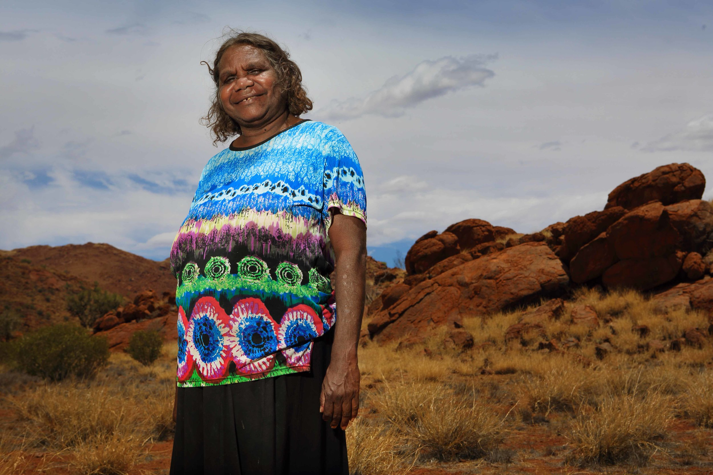

Birth date: 04/03/1958
Birth place: Pukatja Community, APY Lands, SA
Language: Pitjantjatjara

Alison is a senior community and cultural leader in Pukatja community where she was born and raised her family of five children and five grandchildren. Her late husband Pepai Carroll was also a strong leader and spokesperson for the community, where he was the policeman and a successful artist.

Alison is a multi-talented artist, working mainly in the medium of ceramics, as well as having held the position of manager and chairperson at the community art centre, Ernabella Arts.

Group Exhibitions

2026 Winter, Everywhen Artspace, Mornington Peninsula, VIC
2025 TWENTY, Sabbia, Sydney, NSW
2024 H O M E, Everywhen Art, Mornington Peninsula, Victoria
2021 Desert Mob 30, Araluen Arts Centre, Alice Springs NT
2020 Tarnarthi Aboriginal and Torres Strait Islander Art: Open Hands, Art Gallery of South Australia, Adelaide, SA
2020 Talking Blak to History, National Museum of Australia, Canberra ACT
2020 Salon de Refuse, Charles Darwin University Gallery Flying Colours, Talapi Gallery, Alice Springs, NT
2019 Before Time Began: Contemporary Aboriginal Art, Collaborative artwork. Fondation Opale, Lens, Switzerland
2019 Wanapari - in a line, following one another, JamFactory Craft and Design Centre, Adelaide, VIC
2019 Desert Lines: Batik from Central Australia, Bendigo Art Gallery, VIC
2019 An Idea Needing to be Made: Contemporary Ceramics, Heide Museum of Modern Art, Bulleen, VIC
2019 MANIFEST: The art, craft and design of contemporary Australian ceramics, Princes Wharf 1, Hobart, TAS 2019 Berder. Gaba. Urrknga. Wantja., Nishi Gallery, Canberra ACT
2018 Desert Mob 2018, Araluen Art Centre, Alice Springs, NT
2017 Nyuyuntjaku - Keeping the fire alive | New paintings & ceramics by the artists of Ernabella Arts, Harvey Arts, USA
2017 In These Hands: Mara Nyangangka, Sturt Gallery, Mittagong NSW
2017 Nganampa Kililpi Kuwartija Tjuta pakani: Our Rising Stars II, Hazelhurst Regional Gallery, Sydney, NSW 2017 Clay Stories: Indigenous ceramics from remote Australia, Sabbia Gallery, Sydney NSW
2016 Nganampa Kililpil: Our Stars, Hazelhurst Regional Gallery & Arts Centre
2016 Inheritance - Salt Contemporary, Queenscliff, VIC
2016 Point of difference - Desert to the Sea, Artitja Fine Art, Fremantle, WA
2016 Desert Mob - Araluen Art Centre, Alice Springs NT
2016 Indigenous Ceramics Art Award 2016, Shepparton Art Museum, VIC
2016 Pukatjalanguru kungka tjuta kunpu warkarinytja | Ernabella women: strong work, together, Sabbia Gallery, Sydney, NSW
2015 Yangupala Tjuta Waakarinyi (Many Young People Working), Sabbia Gallery, Paddington NSW
2014 Ngura Kutjupa, Tjukurpa Kutju (Different Country, Same Story), ReDot Fine Art Gallery, Singapore
2014 Fragrant Lands – Exhibition of Chinese and Australian Indigenous Art, Shanghai Urban Planning Exhibition Centre, Shanghai, China
2014 Desert Mob 2014, Araluen Art Centre, Alice Springs NT
2014 Fragrant Lands – Exhibition of Chinese and Australian Indigenous Art, Tandanya, Adelaide SA
2014 Indigenous Ceramic Art Award, Shepparton Art Museum, Shepparton VIC
2014 Tjungu Warkarintja: Fifteen Years (Working Together), Sabbia Gallery, Paddington NSW
2013 Putitja (From the Bush), Strathnairn Arts, Canberra ACT
2012 Tjamuku Kamiku Tjukurpa, Outstation Gallery, Darwin NT
2012 Ngapartji Ngapartji, Canberra Playhouse Theatre, Canberra ACT
2012 Ngayuku Ngura, Ngayuku Tjukurpa (My Country, My Story), SA Museum, Adelaide SA
2011 Tjukurpa nyangatja ngananala unngu ngaranyi, Aboriginal and Pacific Art, Sydney NSW
2011 Mark Making, Sabbia Gallery, Paddington NSW
2011 Continuum (SALA), Marshall Arts, Adelaide SA
2011 Ernabella Undiscovered, Tunbridge Gallery, Margaret River WA
2011 Strong Women Strong Painting Strong Culture, Cessnock Regional Art Gallery, Hunter Valley NSW
2011 Ngura kutjara - wangka mantanguru, Strathnairn Gallery, Canberra ACT
2011 Ngura Kutju, Tjukurpa Pulkatjara, Short St Gallery, Broome WA
2010 Ara irititja munu ara kuwaritja Ernabella-la, Alcaston Gallery, Melbourne VIC
2010 Ngayuku Ngura (My Country), Jam Factory, Adelaide, SA
2009 Ernabella Ceramics, Birrung Gallery, Sydney, NSW
2008 Across the Desert: Aboriginal Batik from Central Australia, National Gallery of Victoria, Melbourne, VIC 2008 Desert Mob - Araluen Centre, Alice Springs, NT
2008 Nganampa warka wiru (Our work is beautiful), Cudgegong Gallery, Gulgong, NSW
2008 Nganampa Tjukurpa: Our Stories, Indigenart (Mossenson Galleries), Perth, WA
2008 Our Mob - Adelaide Festival Centre, Adelaide, SA (then touring regional SA through Country Arts SA)
2008 Kiti Art - New Batik from Ernabella - Fabric of Life (Fringe Festival), Adelaide, SA
2008 Desert Mob, Araluen Cultural Precinct, Alice Springs NT
2007 Ernabella – A Collection of New Works, Australia Dreaming Art, Melbourne Divas of the Desert, Gallery Gondwana, Alice Springs, NT
2007 Alice Springs Beanie Festival, Araluen Cultural Precinct, Alice Springs NT
2006 Fabric of Life - Adelaide Homeland/Heartland, JamFactory, Adelaide, SA
2003 Hogarth Gallery - Sydney NSW
2003 Jam Factory - Adelaide SA
2001 Edinburgh City Art Gallery, Edinburgh, Scotland
2001 British Museum, London, England
1999 Contemporary Australian Craft, Hokkaido Museum of Modern Art, Shiga, Japan
1998 Threefold; an exhibition in three parts for shift, Canberra School of Art, Canberra
1998 Mil Arte Gallery, London, England
1997 Superb munu Deadly, Jam Factory Craft and Design Centre, Adelaide, SA
1997 Women’s Work, Land and Spirit, WAPECC 1997-1999, travelling Australia
1997 Dreamings of the Desert, Art Gallery of South Australia, SA
1996 Objects from the Dreaming, Art Gallery of South Australia, Adelaide, SA
1996 Great Lengths, Araluen Centre for Art and Entertainment, Alice Springs, NT
1995 KOLOA, WAPEC, Beijing, China and travelling
1994 Irene Sutton Galleries, Melbourne, VIC

AWARDS
2020 Australia Council of the Arts, Red Ochre Award – Awarded

COLLECTIONS
National Museum of Australia
National Gallery of Australia
British Museum

