Charmaine Pwerle

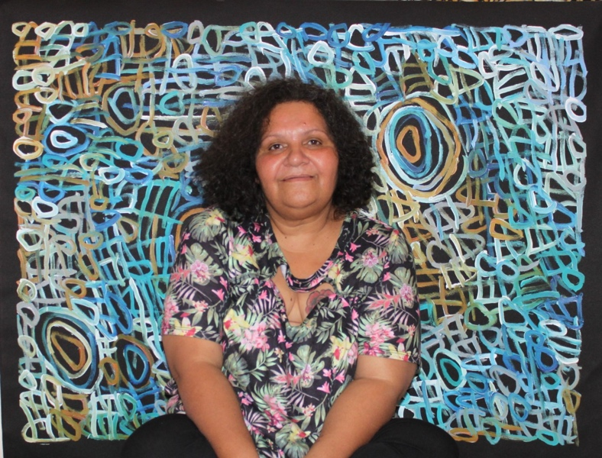

Date of Birth: 1976
Place of birth: Alice Springs
Language: Anmatyerre

Charmaine Pwerle is an Anmatyerre woman born in Alice Springs in 1976. She grew up on the Utopia homelands and went to school in Adelaide as well as living and working in Melbourne before returning to live in Alice Springs and her Utopia lands. Her mother is famed painter Barbara Weir and her grandmother the equally famous Minnie Pwerle - the rights to whose stories she has inherited and which she paints. Other famous women painters close to Charmaine include her great aunts Emily, Galya and Molly Pwerle and her extended family relatives Gloria Petyarre and the late Emily Kame Kngwarreye.

A fully initiated woman, Charmaine has four children and lives at Irrultja on the Utopia lands.

Always a talented artist her work has developed a great vivacity and surety as she herself matures and has the rights, through initiation and heritage, to paint the stories and the country of her grandmother, Minnie Pwerle with whom she spent much time as a young woman. The large circular images in her paintings represents ceremonial sites, the linear design represents the tracks used when searching for food. The small circular designs are the seeds of the bush melon seed and the curvilinear shapes depict ‘Awelye’ or women’s ceremonial body-paint design.

Charmaine Pwerle’s work is highly sought after by galleries and collectors.

Collections

National Gallery of Victoria, Melbourne
The Holmes a Court Collection, Perth
Group exhibitions

2026 At Home with Art – Women’s Show, Everywhen Artspace, Mornington Peninsula, VIC
2025 Gifts Exhibition, Everywhen Artspace, Mornington Peninsula, VIC
2025 Awelye: The Legacy of Utopia, Everywhen Artspace, Mornington Peninsula, VIC
2025 Ties That Bind: Family Matters, Kate Owen Gallery, Sydney, NSW
2024 ICONIC, Kate Owen Gallery, Sydney, NSW
2024 20 years | Keep the Fire Burning, Art Mob, Hobart, TAS
2024 Black + White, Kate Owen Gallery, Syndey, NSW
2023 Emily & Others | Geniuses from Utopia, Art Mob, Hobart, TAS
2023 Winter Salon, Everywhen Artspace, Mornington Peninsula, VIC
2023 Autumn Salon, Everywhen Artspace, Mornington Peninsula, VIC
2023 Antwengerro – Our Home, Our Country, Kate Owen Gallery, Sydney, NSW
2023 Central Desert Showcase, Kate Owen Gallery, Sydney, NSW
2023 Colours of Utopia, SALT Contemporary, Queenscliff, VIC
2022 Connection, National Museum of Australia, Canberra
2022 Into the Sunset, Pwerle Aboriginal Art Gallery, Sydney
2022 In Black and White, Everywhen Artspace, Mornington Peninsula, VIC
2022 Colour Pop, Kate Owen Gallery, Sydney
2022 New Utopia, Everywhen Artspace, Mornington Peninsula, VIC
2022 Art Mob's 20th Birthday Exhibition, Art Mob, Hobart
2022 The Summer Collector’s Show 2022, Everywhen Artspace, Mornington Peninsula, VIC
2022 Palya - a tribute to Steve Ariston, Art Mob, Hobart
2020 Summer Collector’s Show 2020, Everywhen Artspace, Mornington Peninsula, VIC
2020 Colours of Spring, Kate Owen Gallery, Sydney
2020 In Black and White, Everywhen Artspace, Mornington Peninsula, VIC
2020 Top Ten - Our Most Popular Artists 2019, Kate Owen Gallery, Sydney
2019 Colours of my Country, Everywhen Artspace, Mornington Peninsula, VIC
2019 Summer Show & Art Parade, Salt, Queenscliff, VIC
2019 BP Centenary Celebration Exhibition (touring nationally)
2019 defining tradition | black + white, Kate Owen Gallery, Sydney
2019 International Women's Day, Kate Owen Gallery, Sydney
2019 defining tradition | the colurists, Kate Owen Gallery, Sydney
2018 Spring Colours, Kate Owen Gallery, Sydney
2018 My Country, Salt, Queenscliff, VIC
2018 Earth's Creation, Emily Kame and Family, Kate Owen Gallery, Sydney
2018 Delmore Gallery: Utopia Women, Merricks Art Gallery, Victoria, Australia
2017 Sacred Marks, JGM Gallery, London, U.K.
2017 Utopia: the artists of Delmore Downs, Yaama Ganu Gallery, Moree
2016 Winter Salon, Whistlewood, Shoreham, VIC
2015 Sixteen Artists, Japingka Gallery, Perth, WA
2015 Alpitye Art Studio, Alice Springs, NT
2014 Far North-Great South, Le Mans Contemporary Arts (MAC), Collegiate Church of St Pierre La Cour, Paris, France

Solo exhibitions
2025 Continuing a Legacy, Kate Owen Gallery, Sydney, NSW
2023 Charmaine Pwerle: Storylines, FireWorks Gallery, Brisbane, QLD
2022 Charmaine Pwerle, Kate Owen Gallery, Sydney, NSW
2018 Charmaine Pwerle - New Traditions, Kate Owen Gallery, Sydney
2015 Awelye – Charmaine Pwerle, ARTMOB, Hobart, TAS

