Bernadine Kemarre

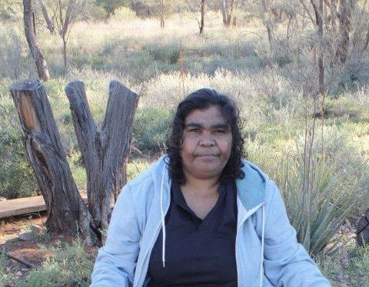

Date of Birth: 1974
Place of birth: Santa Teresa, NT
Language: Arrernte

Bernadine Kemarre is an Arrernte woman born in 1974 at Santa Teresa, NT. She moved to the Eastern Desert community of Utopia to marry Stephen Price Pitjarra the brother of well known artist Anna Price Petyarre.

In her art Bernadine follows the great tradition of many of Utopia’s famous women artists such as Gloria Petyarre whose paintings are of bush medicine leaves, bush tucker and other plants of her lands. The style of her bush medicine leaves paintings is highly detailed and she is a skilled colourist, blending many shades of similar or complementary colours together with great skill. Bush Medicine Leaves are collected by the women and are used in a variety of different ways. They can be boiled in water and the liquid used as a drinking medicine. This medicine can ease stomach-ache. The leaves can also be crushed and mixed with Kangaroo Fat to create a salve that is applied to burns.

As a bush woman, Bernadine is familiar with her land and its abundance of bush tucker species, medicine plants and native fauna. These are the stories inherited by her, along with important women’s stories, and which form the basis of her paintings.

Since she started painting in the late 1990s, Bernadine’s work has become more refined and is eagerly sought after by collectors and art enthusiasts throughout Australia and internationally.

Group Exhibitions
2026 At Home with Art | International Women’s Day, Everywhen Artspace, Mornington Peninsula, VIC
2026 Art for Nepean | Fundraising event, Everywhen Artspace, Mornington Peninsula, VIC
2025 Awelye | The Legacy of Utopia, Everywhen Artspace, Mornington Peninsula, VIC
2023 Synergy, Fundraising Exhibition in partnership with Xaiver Collage, Everywhen Artspace, at Xaiver Collage, Melbourne, VIC
2023 WEST MEETS EAST, Everywhen Artspace, Mornington Peninsula, VIC
2023 The Summer Show 2023 | Grand Design, Everywhen Artspace, Mornington Peninsula, VIC
2022 Synergy | First Nations Artists from around Australia, Everywhen Artspace at Xaiver Collage, Melbourne, VIC
2022 Winter Salon, Everywhen Artspace, Mornington Peninsula, VIC
2022 New Utopia | Next and Leading gen artists from Utopia, Everywhen Artspace, Mornington Peninsula, VIC
2022 The Summer Collector’s Show, Everywhen Artspace, Mornington Peninsula, VIC
2021 Synergy: Art from the Heartlands of Aboriginal Australia, Fundraising Exhibition in partnership with Xaiver Collage, Everywhen Artspace, at Xaiver Collage, Melbourne, VIC
2021 Summer Collectors Show, Everywhen Artspace, Mornington Peninsula, VIC
2020 Bush Medicine Country | Plants of Vitality, Everywhen Artspace online exhibition, Mornington Peninsula, VIC

