Atipalku Intjalki

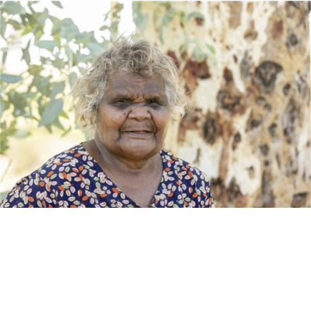
Birth Date: 20/02/1955
Birthplace: Pukatja Community, APY Lands, SA
Language: Pitjantjara

I was born in Ernabella, I started working in the Ernabella Arts when they were doing bark, wool rugs and weaving, over 50 years ago.

Now I paint and I have for a long time. In my painting I am passing on my mother’s story. I have contributed to many exhibitions both national and international.

Group Exhibitions

2026 At Home with Art – Women’s Show | Everywhen Artspace, Mornington Peninsula, VIC
2025 Ernabella Arts Summer | Everywhen Artspace, Mornington Peninsula, VIC
2025 Gift Exhibition | Everywhen Artspace, Mornington Peninsula, VIC
2025 Founding Artists Summer | Everywhen Artspace, Mornington Peninsula, VIC
2025 Synergy | Everywhen Artspace at Xaiver Collage, Melbourne, VIC
2024 Summer Collector’s Show | Everywhen Artspace, Mornington Peninsula, VIC
2024 H O M E | Everywhen Artspace, Mornington Peninsula, VIC
2024 Minyma Ku Tjukurpa (Women’s Lore) | Everywhen Artspace, Mornington Peninsula, VIC
2023 Summer Collectors Show: Grand Design, Everywhen Artspace, Mornington Peninsula, VIC
2022 Manta Tjula – Soft Earth | Short Street Gallery, Broome, WA
2022 Ernabella-ku Tjukurpa: Stories from Ernabella, Everywhen Artspace, Mornington Peninsula, VIC
2021 Caress the Earth: Manta Ngura Atuntju Kanyini - Aboriginal Signature, Bruxelles, Belgium
2021 Three Ladies from Ernabella: Minyma Mankurpa Ernabella la Nguru - Everywhen Artspace, Mornington Peninsula, VIC
2021 Desert Mob 30 - Araleun Arts Centre, Alice Springs, NT
2021 Ernabella Arts Group Exhibition - Outstation, Darwin, NT
2021 Ananyi Nyurakutu- Going Home - Artitja Fine Art Gallery, South Fremantle, WA
2020 Cultural Connections: the gift of story - Artitja Fine Art, South Fremantle
2020 Tarnarthi Aboriginal and Torres Strait Islander Art: Open Hands - Art Gallery of South Australia, Adelaide, SA
2020 Colours of Spring - McCulloch & McCulloch/Salt Contemporary Art, VIC
2020 Spring Salon Art - Artitja Fine Art, York, WA
2020 Ernabella Arts: About place - Artitja Fine Art, South Fremantle
2020 Flying Colours - Talapi Gallery, Alice Springs, NT
2019 Summer Salon - APY Gallery, Sydney NSW
2019 Wanapari - in a line, following one another - JamFactory Craft and Design Centre, Adelaide, VIC
2019 Desert Lines: Batik from Central Australia - Bendigo Art Gallery
2018 Bush Christmas - Talapi Gallery, Alice Springs, NT
2018 Spring Salon Art + Objects - York Festival, Artitja Fine Art, York, WA
2018 Bold and the Beautiful - Talapi Gallery, Alice Springs, NT
2016 Art from the APY Lands - Woolloongabba Art Gallery, Brisbane, QLD
2015 NGANAMPA NGURA, NGANAMPA TJUKURPA – Our Land, Our Stories - Artitja Fine Art, South Fremantle
2015 Colour your world - Artitja Fine Art, South Fremantle
2014 Tjungu Warkarintja: Fifteen Years - Sabbia Gallery, Paddington NSW
2013 Our Mob 2013 - Adelaide Festival Centre, Adelaide SA
2013 A Love of Country: The Indigenous Perspective - Seymour College, Adelaide SA
2012 Ngayuku Ngura, Ngayuku Tjukurpa - SA Museum, Adelaide SA
2012 Tjukurpa Mulapa - Redot Gallery, Singapore
2011 Kuwari - Ernabella Arts Now - Chapman Gallery, ACT
2011 New Paintings from Ernabella Arts - Marshall Arts, SA
2011 Ernabella Undiscovered - Tunbridge Gallery, Margaret River WA
2003 Art on a string: Aboriginal threaded objects from the Central Desert and Arnhem Land, Object Gallery, Sydney NSW
1997 Superb munu Deadly - JamFactory Contemporary Craft and Design, Adelaide SA

Collections

ART GALLERY OF SOUTH AUSTRALIA, 1991
NATIONAL GALLERY AUSTRALIA, 1984

