Mukayi Baker

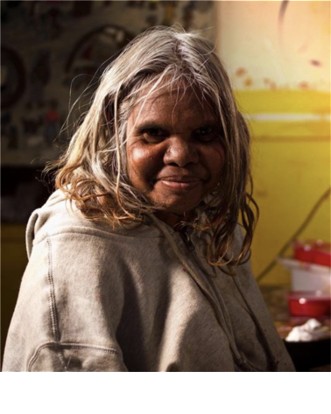
Birth Date: 8/04/1959
Birth Place: Pukatja Community, APY Lands
Language: Pitjantjatjara

Mukayi Baker was an Ernabella Anangu School teacher for many years. She retired in 2012 in order to look after family and paint at the Art Centre. Mukayi is now a full time painter and tjanpi weaver. She paints the important Piltati story from the western APY lands.

Mukayi's paintings have been exhibited many times across Australia, including in Tjungu Warkarintja: Fifteen Years at Sabbia Gallery, Sydney, and in Family at Signal Point Regional Gallery, South Australia. Her art has been acquired for the collections at City of Melville, WA and University of Newcastle, NSW.

Mukayi is also a Ngangkari or traditional Anangu healer.

Group Exhibitions

2022 Aboriginal Signature, Brussels, Belgium - Profundity - Art from the APY Lands
2022 Short St Gallery, Broome, WA - Manta Tjula - Soft Earth
2021 Aboriginal Signature, Bruxelles, Belgium - Caress the Earth : Manta Ngura Atuntju Kanyini
2021 Outstation, Darwin, NT - Ernabella Arts Group Exhibition
2020 Aboriginal Signature, Brussels, Belguim - Nganampa ngura-nguru nyurampa ngurakutu (From our place to
your place)
2018 Signal Point Regional Gallery, Goolwa, SA - Family
2018 Artitja Fine Art, South Fremantle, WA - Winter Studio: Colour Your World
2016 McCulloch & McCulloch/Salt Contemporary Art - All About Colour, Summer Show + Art Parade
2015 Short Street Gallery, Broome - Kuruntu mukuringkula kulira palyantja (Stories straight from the heart)
2014 touring exhibition ARTKELCH @ ARTKELCH, Freiburg, @ Staatliches Völkerkundemuseum, München, @
ARTKELCH Collectors Lounge, Schorndorf, @ Fabrik der Künste, Hamburg und @ Draenert Orangerie,
Immenstaad (Lake Constance), Germany - PRO COMMUNITY – Eastern APY Lands
2014 Talapi, Alice Springs - Bold and the Beautiful
2014 Sabbia Gallery, Paddington NSW - Tjungu Warkarintja: Fifteen Years
2013 Adelaide Festival Centre, Adelaide SA - Our Mob 2013
2013 Seymour College, Adelaide SA - A Love of Country: The Indigenous Perspective
2013 Aboriginal and Pacific Art Gallery, Sydney NSW - Putitja: From Spinifex Country
2012 Canberra Theatre Foyer in conjunction with Chapman Gallery, Canberra ACT - Ngapartji Ngapartji
2010 Araluen Art Centre, Alice Springs NT - Desert Mob 2010
2010 Alcaston Gallery, Melbourne VIC - Ara irititja munu ara kuwaritja Ernabella-la

Themes

Country
Piltati

Mediums

Acrylic on Canvas
Ceramics
Collections

CITY OF MELVILLE, 2016
UNIVERSITY OF NEWCASTLE, 2013

