Janice Stanley

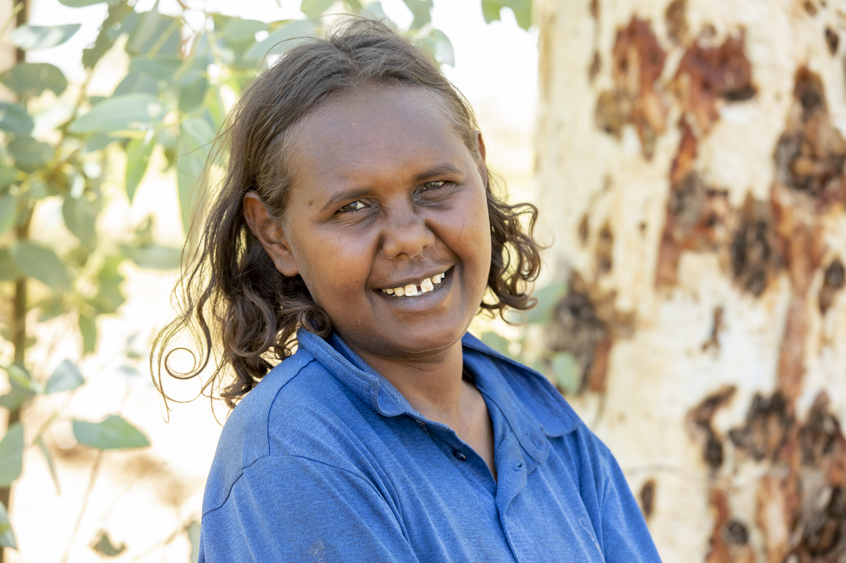

Birth Date: 13/12/1987
Birthplace: Alice Springs, NT
Language: Pitjantjatjara

Janice Stanley is the third generation of Stanley women to create artwork at Ernabella Arts. She is an early career painter and ceramic artist showing great promise.

Her grandmother was founding artist and traditional healer Tjariya Stanley and her aunts are senior artists, Alison Milyika Carroll and Renita Stanley. Janice has two children.

Janice's paintings depict pantu, or salt lakes near Atilla (Mt Connor). This is a significant location for the Seven Sisters creation story. This story tells of seven sisters running across the country creating landforms in their wake. In her paintings Janice imagines viewing the salt lakes from above.

In 2020 she exhibited in Nganampa ngura-nguru nyurampa ngurakutu (From our place to your place) at Aboriginal Signature in Brussels, as well as several national exhibitions. She has been exhibited around Australia and internationally, in Adelaide, Alice Springs, Broome, Freemantle, the Mornington Peninsula, Queenscliff, Sydney and Brussels.

Group Exhibitions
2026 At Home with Art: Women’s Show, Everywhen Artspace, Mornington Peninsula, VIC
2026 Ernbella Summer show, Everywhen Artspace, Mornington Peninsula, VIC
2025 The Creation Circle: Aboriginal Art and Time, Art Contemporary, Seattle, WA, USA
2024 From Sand to Stars | Indigenous Australian Art, Art Contemporary, Seattle, WA, USA
2024 Minyma Ku Tjukurpa Ernabella, Everywhen Art. VIC
2024 Colours of Country, Everywhen Art , Whistlewood, VIC
2024 Pattern and Palette, Everywhen Art, at Salt Contemporary, Queenscliff, VIC
2024 Tribute to Our Elders, Aboriginal Signature, Bruxelles, Belgium
2024 From the Sand, Artitja Fine Art, South Fremantle – Mantanguru
2024 H O M E, Everywhen Art at Whistlewood, Mornington Peninsula, VIC
2023 This Land is Me: Australian Aboriginal Art, Art Contemporary, Seattle, WA, USA
2023 Seattle Art Fair: Booth G05, Art Contemporary, Seattle, WA, USA
2023 NextGen Ernabella, Everywhen Artspace at Sydney Contemporary, Carriageworks, Sydney
2023 Caress the Earth II: Manta Ngura Atuntju Kanyini II, Aboriginal Signature, Bruxelles, Belgium
2023 The Summer Collector’s Show: Grand Designs, Everywhen Artspace, Mornington Peninsula, VIC
2023 Ernabella Arts: Ceramic Warka Wiru 20 Years-kutu – 20 Year of Creating Ceramics, JamFactory Craft and Desgin Centre, Adelaide, SA
2023 Piryakatu – Springtime, Everywhen Artspace, Mornington Peninsula, VIC
2023 Kungkarangkalpa: Seven Sisters, Michael Reid, Berlin, Germany
2022 Desert Colour, Talapi Gallert, Alice Springs, NT
2022 After the Rain, Yaama Ganu Gallery, Moree, NSW
2022 Inunjti Putija (Desert Colours from Ernabella), Artitja Fine Arts, South Freemantle, WA
2022 Ernabella-Ku Tjukurrpa (Stories from Ernabella), Everywhen Artspace, Mornington Peninsula, VIC
2022 Manta Tjula - Soft Earth, Short St Gallery, Broome, WA
2021 Renewal, Art Contemporary, Seattle, WA, USA
2021 Caress the Earth: Manta Ngura Atuntju Kanyini, Aboriginal Signature, Bruxelles, Belgium
2021 Desert Mob 30, Araleun Arts Centre, Alice Springs, NT
2021 Spring Salon, Artitja Fine Art, York, WA
2021 Painting Now: Peindre aujourd’hui en terres aborigènes, IDAIA, Le Havre, France
2021 Ernabella Arts Group Exhibition, Outstation, Darwin, NT
2021 Ananyi Nyurakutu- Going Home, Artitja Fine Art Gallery, South Fremantle, WA
2021 Flying Colours, Talapi Gallery, Alice Springs, NT
2020 Tarnarthi Aboriginal and Torres Strait Islander Art: Open Hands, Art Gallery of South Australia, Adelaide, SA
2020 Nganampa Tjukurpa Ananyi Wilurara (Our Stories Going West), Short Street Gallery, Broome, WA
2020 Ernabella Arts: About place, Artitja Fine Art, South Fremantle, WA
2020 Nganampa Tjukurpa Ananyi Kakarara (Our Stories Going East), Aboriginal Contemporary, Sydney, NSW
2020 I know my Country, Artitja Gallery, South Fremantle, WA
2020 Flying Colours, Talapi Gallery, Alice Springs, NT
2020 Nganampa ngura-nguru nyurampa ngurakutu (From our place to your place), Aboriginal Signature, Brussels, Belguim
2020 Summer Salon, Artitja Gallery, South Fremantle, WA
2019 Desert Mob 2019, Araluen Art Centre, Alice Springs, NT
2019 Desert Colour featuring Ernabella ceramics, Talapi Gallery, Alice Springs, NT
2019 An Idea Needing to be Made: Contemporary Ceramics, Heide Museum of Modern Art, Bulleen, VIC
2019 Uwankara Tjungu (all in), APY Collective Gallery, Adelaide, SA
2019 Anniversary pukulpa. Katu parpakani! (Happy anniversary. Flying high!), APY Collective Gallery, Sydney, NSW
2018 Hold our connection to country strong for malatja-malatja (future generations), Aboriginal Signature, Brussels, Belguim
2017 Spirited – Kurunitja, Short Street Gallery, Broome, WA
2017 Our Country in Clay, Nomad Art, Darwin, NT
2017 Inuntjii – Regeneration, Aboriginal Signature • Estrangin gallery, Bruxelles, BELGIUM
2016 Pukatjalanguru kungka tjuta kunpu warkarinytja | Ernabella women: strong work, together, Sabbia Gallery, Paddington NSW
2016 The Blooming Desert, Talapi Gallery, Alice Springs, NT
2016 Rising Stars 2019: New Directions, Outstation Gallery, Darwin, NT

Collections

Australian Embassy in Zagreb
Janet Holmes A Court Collection
Australian Parliament House

