Anita Pumani

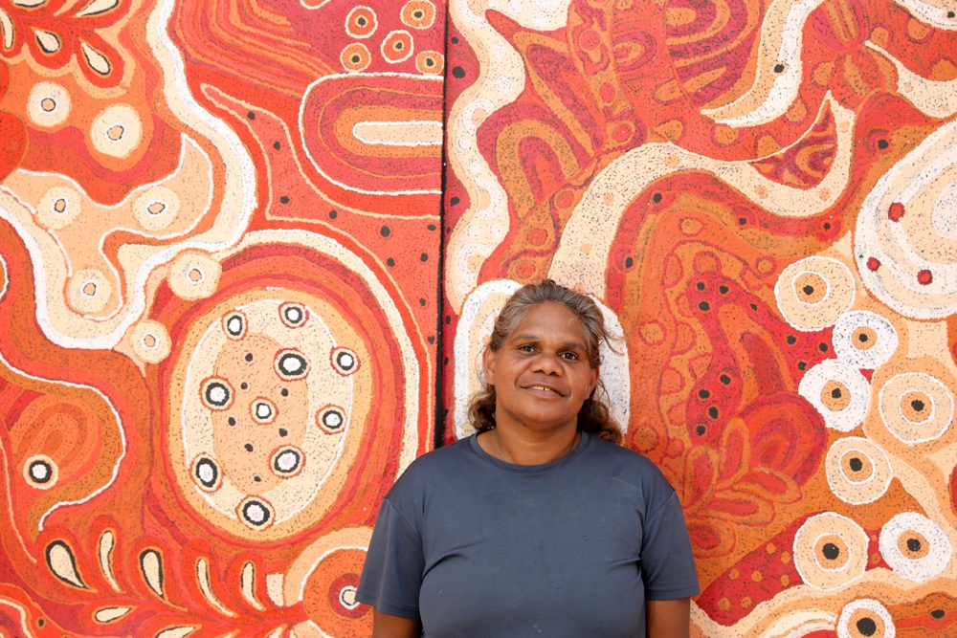
Date of birth: 1982
Place of birth: Indulkana
Language: Pitjantantatjara
Anita Pumani lives at Mimili on the APY Lands in the northwest of South Australia. She grew up in Mimili and attended school in Adelaide.
As the oldest daughter to Teresa Mula and Ken Pumani, both senior cultural leaders in Mimili, she learnt about the importance of Tjukurpa early on. Her grandmother on her father's side was Kunmanara (Milatjari) Pumani - one of the most revered of Mimili's founding artists and her aunt is the award-winning painter, Betty Pumani. Her mother Teresa is one of Mimili Maku’s senior painters. Anita is one of four sisters, and now has three daughters of her own.
Growing up in such a strong line of women, Anita proudly shares women’s stories in her paintings. She often references Antara, an important women’s site close to Mimili community, and paints Maku (witchetty grub) Tjukurpa.
She has collaborated with her mother and her sisters on a number of works relating the Seven Sisters Story, which is deeply engrained in her family line.
Anita is one of the rising stars of her art centre Mimili Maku and has been an exhibiting artist since 2018.
Exhibitions

2026 Art for Nepean, Fundraiser event, Everywhen Artspace, Mornington Peninsula, VIC
2025 Synergy, Everywhen Artspace, Mornington Peninsula, VIC
2025 Regeneration, Everywhen Artspace, Mornington Peninsula, VIC
2025 Women Celebrating Women, Everywhen Artspace, Mornington Peninsula, VIC
2024 Pereip (True Spring), Everywhen Artspace, Mornington Peninsula, VIC
2024 Colurs of Country, Everywhen Artspace, Mornington Peninsula, VIC
2024 Women’s Story – Short Street Gallery, Broome, WA
2024 HOME, Everywhen Artspace, Mornington Peninsula
2023 Minyma Maku, Everywhen Artspace, Mornington Peninsula, VIC
2023 Synergy, Everywhen Artspace partnership with Xaiver Collage, Xaiver Collage, Melbourne, VIC
2022 Pakalarani – Taking Flight, Short St Gallery, Broome
2022 APY Group Show, Aboriginal Signature Estrangin Gallery, Brussels, Belgium
2022 The Summer Collector’s Show, Everywhen Art, Flinders, Vic
2021 Synergy: Art From The Heartlands of Aboriginal Australia, Everywhen Art, Flinders, Vic
2021 Summer Collector’s Show, Everywhen Art, Flinders, Vic
2021 Kuwari - the present, Aboriginal Signature Estrangin Gallery, Brussels, Belgium
2021 Ilykuwara, APY Gallery, Adelaide
2020 Antara: New Generations, Everywhen Art, Flinders, Vic
2020 Tjuntungka – Tomorrow, Short St Gallery, Broome WA
2019 APY Gallery at Sydney Contemporary 2019, APY Gallery, Sydney, NSW
2019 Winter Salon + Art Parade, Everywhen Artspace, Flinders
2019 APY at The Other Art Fair, The Cutaway Barangaroo Reserve, Sydney
2019 Synergy, Purple House Fundraiser, McCulloch&McCulloch, Melbourne
2019 ReGeneration, Everywhen Artspace, Flinders
2019 Bold & Beautiful, Talapi Gallery, Alice Springs
2019 Tjungula warkarima nganampa tjitji tjutaku, APY Gallery, Sydney
2019 APY at The Other Art Fair, Australian Technology Park, Sydney
2019 Nganampa Ngura Kunpu Kanyintaku, APY Gallery, Sydney
2018 Desert Mob, Araluen Arts Centre, Alice Springs
2018 Malatja Tjutangku Ara Irititja Kunpungku, APY Gallery, Sydney
2018 Tjungungku Palyantja: Together all is well, Short St Gallery, Broome
2018 Rising Stars, Outstation Gallery, Darwin
2017 Minyma Tjutaku Tjukurpa, Short St Gallery, Broome

