Caroline Petrick Ngwarreye

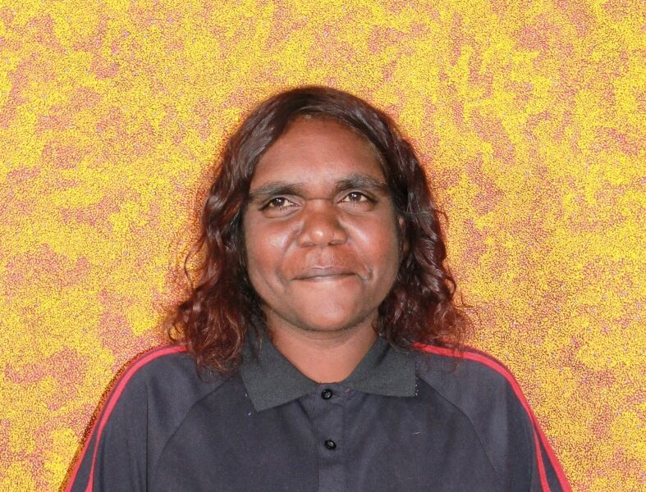

Date of Birth: 1966
Place of birth: Alice Springs, NT
Language: Eastern Arrernte/Alyawarr

Caroline Petrick Ngwarreye is an Eastern Arrernte and Alyawarr women born c 1966. Her traditional country is Irrerlirre approximately 250km northeast of Alice Springs in the beautiful Harts Range. Caroline developed her artistic talents under the tutelage of her mother Jill Kelly Kemarre. Her subtle paintings of intricate patterns of dot work and splashes of colour relate to her mother’s country and stories from Irrwelty. These stories include arnwekety – conkerberry, ntange – seeds and awelye – women’s ceremony. The intricate pattern of dot and line work throughout Carolineʼs painting reflects her mother’s traditional country Irrwelty, which lies on Alyawarre land approximately 300 kms north east of Alice Springs in Central Australia.

Exhibitions
2026 At Home with Art | International Women’s Day, Everywhen Artspace, Mornington Peninsula, VIC
2025 Awelye: The Legacy of Utopia, Everywhen Artspace, Mornington Peninsula, VIC
2025 Regeneration, Everywhen Artspace, Mornington Peninsula, VIC
2025 At Home with Art, Everywhen Artspace, Mornington Peninsula, VIC
2025 Women Celebrating Women, Everywhen Artspace, Mornington Peninsula, VIC
2024 Pareip: True Spring, Everywhen Artspace, Mornington Peninsula, VIC
2024 Colours of Country, Everywhen Artspace, Mornington Peninsula, VIC
2022 In Black and White, Everywhen Artspace, Mornington Peninsula, VIC
2022 New Utopia, Everywhen Artspace, Flinders, VIC
2022 The Summer Collector’s Show, Everywhen Artspace, Mornington Peninsula, VIC
2020 A Vision of Country: Australian Aboriginal Landscapes, Kate Owen Gallery, Sydney, NSW
2019 International Women's Day, Kate Owen Gallery, Sydney, NSW
2017 Gems of the Stockroom, Kate Owen Gallery, Sydney, NSW
2008 Alpitye At Byron, Byron Bay, NSW
2008 Alpitye At Port, Port Macquarie, NSW
2008 Outback Art, Canberra, ACT
2007 Alpitye At Byron, Byron Bay, NSW
2007 Alpitye At Port, Port Macquarie, NSW
2007 Indij Arts, Marysville, VIC
2007 Outback Art, Canberra, ACT

