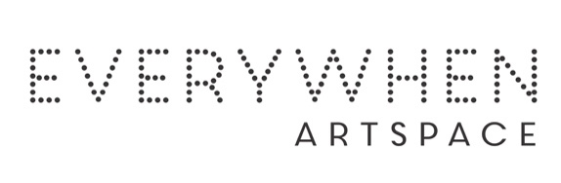

Samson Namundja
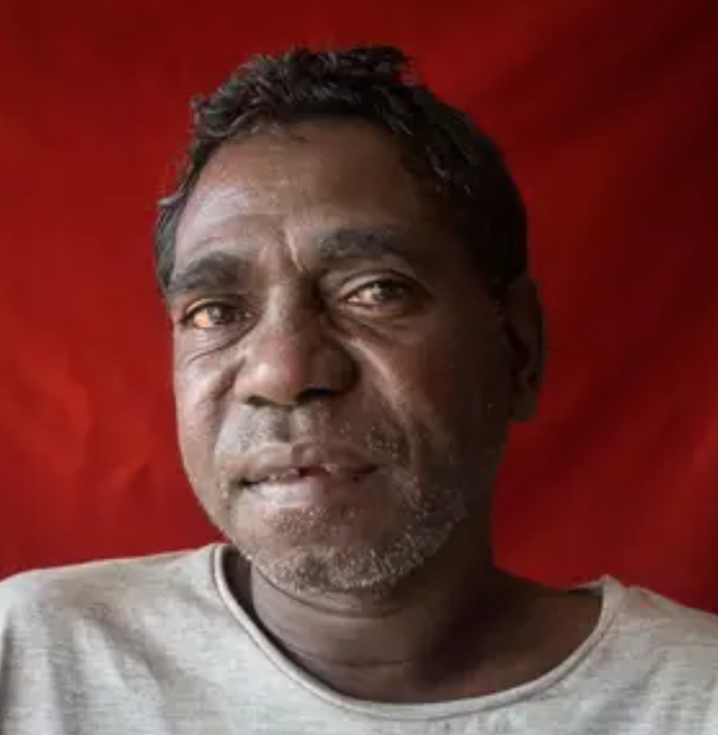

Born: 1969
Community: Openpeli
Language: Kunwinjku

Samson Namundja is the son of Dianne Ginjmulu and Bob Wanurr Namundja. He is from Mankorlod, his skin name is Kamarrang, language Kunwinjku, clan Kardbam and Dreaming Yirridjdja. He lives in Gunbalanya (Oenpelli) community, Northern Territory, and is a member of Injalak Arts centre.
Injalak Arts is an outstanding example of a community organisation that is 100% Aboriginal owned and delivers positive social, economic and cultural outcomes for its 150 artist members.

Group Exhibitions:
2026 Small Works Big Stories, Everywhen Artspace, Mornington Peninsula, VIC

