Atlanta Mercy Umbulgurri

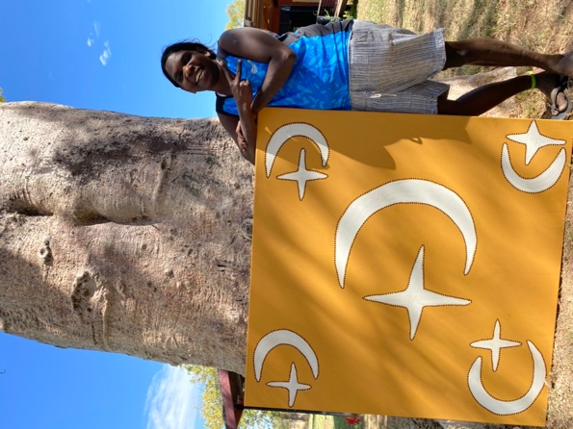

Date of Birth: 5/07/1996
Birthplace: Perth, WA
Language: English, Kimberley Kriol

ATLANTA MERCY UMBULGURRI was born in Perth in 1996 and speaks English and Kimberley Kriol. Her mother is Eileen Juli, one of famous Kimberley artist Mabel Juli's daughters. Mabel Juli has designated Atlanta to be the inheritor of the stories of her paintings and has given her the rights to paint them with her own artistic interpretation. Atlanta comes from a large family of brothers and sisters and lives in the Warmun community, where she says she likes to" go fishing, camping out, basketball and football.' Atlanta has one son Kendrick Chungerai.

Atlanta has been painting since 2008 and was exhibited in 2010 in "Next Generation - Warmun Artists", Tineriba Gallery, SA. In 2021 she exhibited alongside her grandmother Mabel Juli and aunt Marlene Juli in "Garn’giny Not Granite",Everywhen Artspace at The Lennox, Melbourne, Vic. In December 2022 she held her first solo exhibition at Everywhen Artspace, Mornington Peninsula.

Solo Exhibitions

2022 December, Atlanta Mercy Umbulgurri, Gungi to Gungi (Old Days/New Days): The Living Art of Mabel Juli's Dreamings, Everywhen Artspace, Mornington Peninsula, VIC

Group Exhibitions
2023 The Summer Show | Grand Design, Everywhen Artspace, Mornington Peninsula, VIC
2022 ATLANTA MERCY UMBULGURRI | Gungi to Gungi (Old Days/New Ways) – Everywhen Artspace, Mornington Peninsula, VIC
2021 May Garn’giny Not Granite, Mabel Juli, Marlene Juli, Atlanta Mercy Umbulgurri, Everywhen Artspace at The Lennox, Melbourne, VIC
2010 January 'Next Generation - Warmun Artists', Tineriba Gallery, SA
2008 January 'Palya Art in Sydney', Mary Place Gallery, Sydney, NSW

