Belinda Golder Kngwarreye

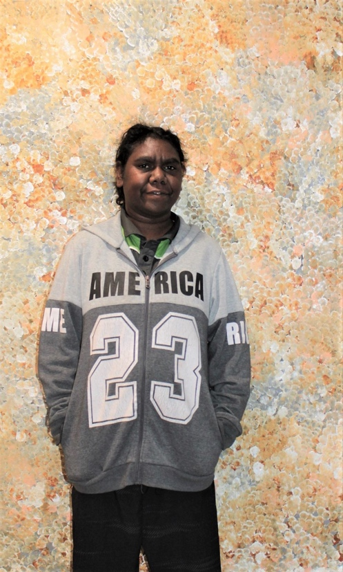

Date of Birth: 1986
Place of birth: Utopia, NT
Language: Anmatyerre

Belinda Golder Kngwarreye was born in 1986 and is an Anmatyerre speaker from the Utopia region of Central Australia, situated approximately 130km north-east of Alice Springs. Belinda comes from a long line of significant and well-established artists. She is the daughter of Bessie Petyarre; her sister is Janet Golder Kngwarreye and both artists are the grandaughters of Polly Ngale. Her great aunts are artists Kathleen Ngale and Angelina Ngale. In her depictions of the seeds, flowers and fruit of the bush plum - an important dreaming story as well as food source for her people. Belinda is following in the footsteps of these, and other highly regarded artists of the Kngwarreye family, especially Emily Kame Kngwarreye, and Kudditji Kngwarreye.

Exhibition
2026 At Home with Art – Women’s Show | Everywhen Artspace, Mornington Peninsula, VIC
2025 At The Gallery | Japingka Gallery, Fremantle, WA
2025 Yallaroo | Galerie Arts d’Australie – Stephane Jacob, Paris
2025 Bush Garden | Japingka Gallery, Fremantle, WA
2024 H O M E | Everywhen Artspace, Shoreham, VIC
2024 Up the Utopia Way | Kate Owen Gallery, Sydney, NSW
2024 ICONIC | Kate Owen Gallery, Sydney, NSW
2023 Emily & Others | Geniuses from Utopia, Art Mob, Hobart, TAS
2023 The Summer Showe 2023 | Grand Design, Everywhen Art, Shoreham, VIC
2022 Synergy 2022: First Nations Artists from around Australia |Everywhen Artspace, Shoreham, VIC
2021 Sounds of Summer 2 | Japingka Gallery, Fremantle, WA
2021 Synergy: Art from the Heartlands of Aboriginal Australia | Everywhen Artspace, Shoreham, VIC

Awards
2023 2023 Fisher’s Ghost Art Award, Campbelltown, NSW – Finalist

