Ada Pula Beasley

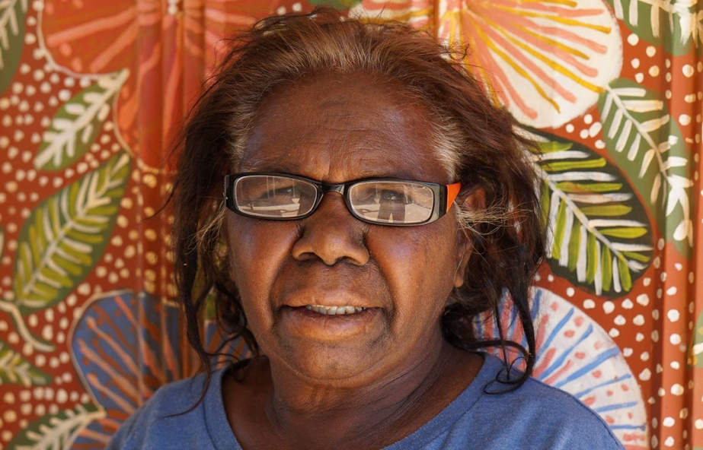

Date of Birth: 22/01/1951
Place of Birth: Ampilatawatja
Language: Alyawarre

Ada Pula Beasley was born in 1951 and started painting with Artists of Ampilatwaja in 2012. She is the sister of artist Michelle Pula Holmes and the daughter of Artist Jilly Holmes.

Ada is very interested in preserving her culture and teaching the younger artists about country and bush medicines, these include Mulga and Witchetty trees, native fuschia, river red gum, spinifex grass and the many varieties of bush flower. Her landscape works have been exhibited in leading galleries around Australia since 2013 and have become highly sought after for their beautiful colours and sense of scale.
Exhibitions

2026 Art for Nepean: Fundraising Event, Everywhen Artspace, Mornington Peninsula, VIC
2025 ANATY ANATY APMER (Heartland), Everywhen Artspace, Mornington Peninsula, VIC
2024 Winter Salon | Warm Hues & Winter Lights, Everywhen Artspace, Mornington Peninsula, VIC
2024 WILDLIFE!, Everywhen Artspace, Mornington Peninsula, VIC
2024 Autumn Salon, Everywhen Artspace, Mornington Peninsula, VIC
2023 Sea, Sand & Salt, Everywhen Artspace, Mornington Peninsula, VIC
2023 Synergy 2023, Xaiver Collage in partnership with Everywhen Artspace, C
2023 Winter Salon, Everywhen Artspace, Mornington Peninsula, VIC
2023 The Summer Show 2023, Everywhen Artspace, Mornington Peninsula, VIC
2022 Winter Salon, Everywhen Artspace, Mornington Peninsula, VIC
2022 New Utopia, Everywhen Artspace, Mornington Peninsula, VIC
2021 Synergy, Everywhen Artspace at Xavier College, Melbourne, VIC
2021 We Choose to Challenge, Coo-ee Fine Art Gallery, Sydney
2021 Winter Salon, Everywhen Artspace, Mornington Peninsula, VIC
2020 Painters from Ampilatwatja – Living in the Natural World, Japingka Gallery, Perth
2020 A Vision of Country: Australian Aboriginal Landscapes, Kate Owen Gallery, Sydney
2020 Talapi Gallery, Alice Springs
2019 Bush Garden – Artists of Ampilatwatja, Japingka Gallery, Fremantle, WA
2019 Mwerr-angker Alpert (Pretty Flower), Brisbane
2018 Artists of Ampilatwatja – Welcome to Paradise, Japingka Gallery, Fremantle, WA
2018 Talapi Gallery, Alice Springs, NT
2018 Flinders Lane Gallery, Melbourne
2017 Talapi Desert Soft Light, Alice Springs NT
2014 Wolloongabba Art Gallery, Brisbane QLD

