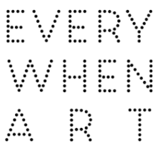
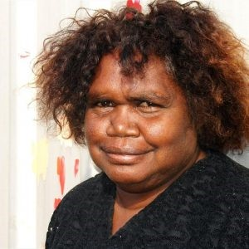
Ursula Napangardi Hudson
Ursula Napangardi Hudson was born in 1962 in Yuendumu, a remote Aboriginal community located 290 km north-west of Alice Springs in the NT of Australia. Ursula attended the local school. When she finished she did odd jobs before marrying Mika Hudson, a pastor in Nyirripi, where she has lived ever since. Nyirripi is located a further 150 kms west-south west of Yuendumu. She has three children and six grandchildren.
Ursula has been painting with Walukurlangu Artists Aboriginal Corporation, an Aboriginal owned and governed art centre located in Yuendumu, since 1993. The Art Centre makes regular visits to Nyirripi to drop off canvas, paint and brushes for the artists and to collect finished artwork. When Ursula was young she would watch her Aunty, Daisy Napanangka Nelson (Circa 1930 – 2002), paint. “She taught us to paint. I wanted to paint, to teach my kids when they grew up. Tell them the stories, tell the bush tucker stories when they go hunting.”
Ursula paints her father’s Yuparli Jukurrpa (Bush Banana Dreaming) and Pikilyi Jukurrpa (Vaughan Springs Dreaming), which her Aunty taught her and her mother’s Ngapa Jukurrpa (Water Dreaming).
These dreamings have been passed down the generations for millennia and relate directly
to the land, its features and the plants and animals that inhabit it. Ursula uses an unrestricted palette to develop a modern interpretation of her traditional culture. On weekends, when Ursula is not painting, she likes to go hunting for honey ants and goanna.

Group Exhibitions:
2025 Warlu Feature, Everywhen Artspace, Mornington Peninsula, VIC
2025 Synergy, Everywhen Artspace, Mornington Peninsula, VIC
2024 Pareip (Ture Spring), Everywhen Artspace, Mornington Peninsula, VIC
2024 Winter Salon, Everywhen Artspace, Mornington Peninsula, VIC
2024 Art Parade/Autumn Salon, Everywhen Artspace, Mornington Peninsula, VIC
2022 In Black + White: Aboriginal Art in Monochrome, Everywhen Artspace, Mornington Peninsula, VIC
2021 Synergy: Art from the Heartlands of Aboriginal Australian, Xaiver Collage in Partnership with Everywhen Artspace, Mornington Peninsula, VIC
2021 Arts d'Australie, Stéphane Jacob at Art Paris, Paris, Fance
2020 Arts d'Australie, Stéphane Jacob at LE PARIS, Paris, France
2019 Winter Salon, Everywhen Artspace, Mornington Peninsula, VIC

