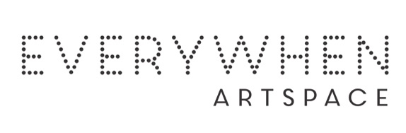

Roland Burrunali
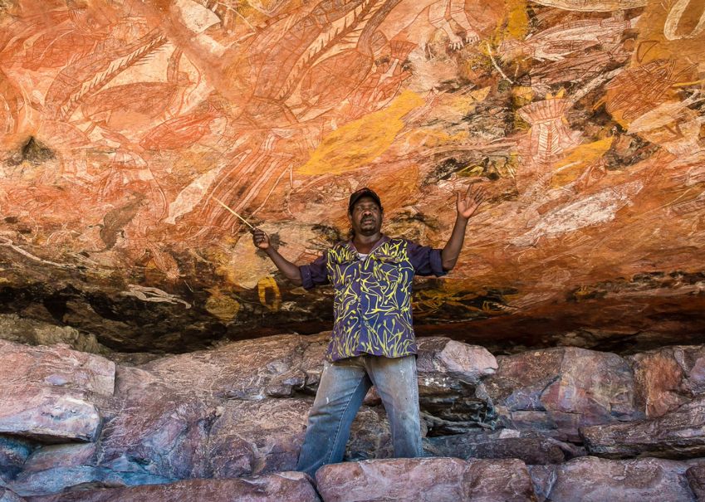

Born: 1973
Region: Gunbalanya, Western Arnhem Land, NT
Language: Kunwiniku

Roland Burrunali is the son of Marlene and Isaiah Burrunali. Roland is the Djungkayi (ritual manager) for Namorrordo, the devil-like spirit man. cAs well as being a gifted artist, Roland guides tours of Injalak Hill and shares his extensive knowledge of the rock art with tourists from all around Australia and the world. He is also a member of the Injalak Arts Management Committee.
In July 2016 Roland represented Injalak Arts at the Wearables exhibition at the Festival del Caribe in Santiago de Cuba. In 2017 he was selected as a finalist in the National Aboriginal and Torres Strait Islander Art Awards (NATSIAA).

Kunwinjku art is part of the oldest continuous art tradition in the world. Ancestors of today’s artists have been painting the rock walls of West Arnhem Land for tens of thousands of years. The traditional palette of white, red, yellow and black comes from the ochre that naturally occurs in the region, although contemporary artists sometimes choose to paint in acrylics as well. Kunwinjku artists famously paint using either the traditional rarrk hatching technique, or the more contemporary and complex cross hatching technique which has been adapted from ceremonial painting. These lines are painted using a manyilk, which is a piece of sedge grass shaved down until only a few fibres remain.

Group Exhibitions:
2026 Small Works, Big Stories, Everywhen Artspace, Mornington Peninsula, VIC
2021 Northern Waters Exhibition, Short St Gallery, Broome, WA
2017 ‘Wearables Festival del Caribe Santiago de Cuba’, Santiago de Cuba
2016 ‘34th National Aboriginal and Torres Strait Islander Art Awards’ (NATSIAA), Darwin, NT

