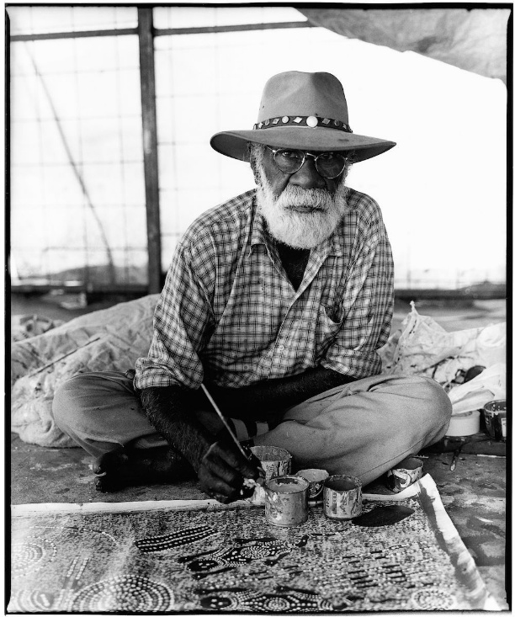
Wenten Rubuntja
(1923 - 2005)
Language group: Arrernte

Wenten Rubuntja was an influential Arrernte artist, activist, and community leader born 1926 from the town of Burnt Creek, north of Mparntwe (Alice Springs). Inspired by his uncle Albert Namatjira, he learned painting by secretly practicing the techniques he observed from his unlce, eventually becoming a respected artist himself. Before focusing on art, Rubuntja worked as a stockman and jockey across Central Australia.
He became known for painting in both the Hermannsburg watercolour tradition and the Papunya dot style. Rubuntja's work focused on the landscapes and traditions of Mparntwe and often considered themes of identity and Dreaming. He explained: "The landscape painting is the country itself, with tywerrenge [sacred objects] himself. Tywerrenge and songs come out of the body of the country. […] That stone, that mountain has got Dreaming. We sing that one, we've got the song.". As the senior custodian of the Yeperenye (Caterpillar) Dreaming, he played an important cultural role in the Alice Springs region.
Rubuntja was also a major Aboriginal rights activist. He helped lead the Central Land Council, campaigned for land rights, and co-presented the Barunga Statement to Prime Minister Bob Hawke in 1988, calling for a treaty with Indigenous Australians. He co-founded important organisations such as the Tangentyere Council and Yipirinya School. In 1995, he was awarded a Member of the Order of Australia for his contributions to Indigenous culture and advocacy.
His works are held in the National Gallery of Australia, The Royal collection, The National Gallery of Victoria and many other collections. Pope John Paul II visited Alice Springs in 1986 and was presented with one of his paintings. A large acrylic canvas of Caterpillar Dreaming by Wenten hangs in the Prime Minister's Office in Parliament house. A photograph of Rubuntja by Greg Weight, taken in 1998, hangs in the National Portrait Gallery of Australia.

Exhibitions
His work Yeperenye Dreaming (2000) is currently on display in the Grand Vestibule, Windsor Castle as a part of the Grand Vestibule: The British Monarchy and the World show

Small Works, Big Stories, Everywhen Artspace, Mornington Peninsula, VIC
1 – 28 June 2026

Lineage & Legacy , Araluen Arts Centre Galleries, Alice Springs
Nov 06, 2020 - Sep 12, 2021

The TERRA Within, Shoalhaven Regional Gallery, Nowra Australia
Oct 10, 2020 - Dec 05, 2020

Tarnanthi, Art Gallery of South Australia
Oct 18, 2019 - Jan 27, 2020

Action and Consequence, Campbelltown Arts Centre
Dec 20, 2017 - May 20, 2018

