SHIRLEY PURDIE Birrmarriya

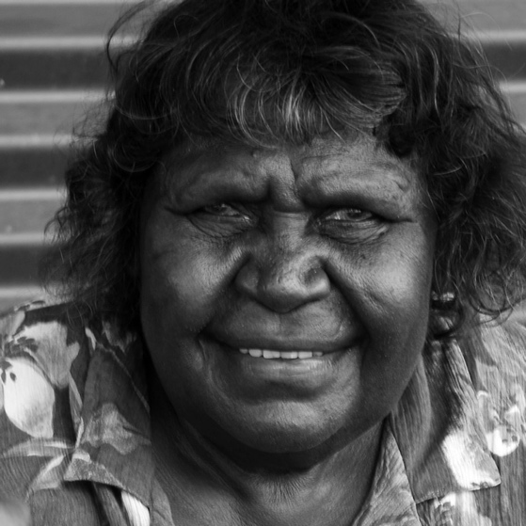

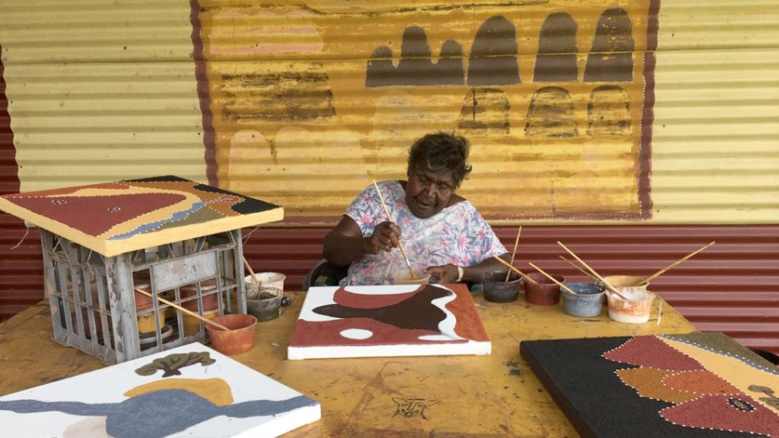

Date of Birth: 10/06/1947
Language: Ngarrangarni / Totem: Crow
Skin: Nangari
Languages: English, Gija, Kimberley Kriol
Birth Place: Gilban - Mabel Downs Station

Biography
Birrmarriya Shirley Purdie has been pain􀆟ng for more than twenty years and is an artist of great significance and seniority. Her cultural knowledge and artistic skill complement each other to produce a practice that holds great strength. Shirley is also a prominent leader in Warmun community and an incisive cross-cultural communicator.
Inspired by more senior Warmun artists including her late mother, the great Madigan Thomas, as well as Rover Thomas and Queenie McKenzie, Shirley began to paint her country in the early 199tis. Shirley’s uncle, artist Jack Britten, said to her, ‘Why don’t you try yourself for pain􀆟ng, you might be all right.'

Shirley says: 'It’s good to learn from old people. They keep saying when you paint you can remember that country, just like to take a photo, but there’s the Ngarranggarni (Dreaming) and everything. Good to put it in pain􀆟tig, your country, so kids can know and understand. When the old people die, young people can read the stories from the paintings. They can learn from the paintings and maybe they want to start painting too.’

Shirley’s body of work explores sites and narratives associated with the country of her mother and father and is characterized by a bold use of richly textured ochre.

Significant places such as Baloowa, Jirragin and Gilban lie on Country now taken in by Violet Valley and Mabel Downs cattle stations.

Much of her work also explores spirituality and the relationship between Gija conceptions of Ngarranggarni (Dreaming) and Catholicism.

In 2007 Shirley was awarded the Blake Prize for Religious Art for her major work Stations of the Cross.

Colonial histories of the region also figure in Shirley’s work in which she relates accounts of early contact, massacre, warfare and indentured labour since the incursion of pastoralists into Gija land in the late 1800s.

Shirley is presently working on a major publication of great cultural and ecological value, documenting through painting and in Gija language the plants and trees of her country - Goowoolem Gijam.

Themes
Barluwan & Garlunggurrji - Norton Bore and Violet Valley stories
Massacre stories (Mistake Creek)
Stories of station life & family
Traditional stories for Ngarranggarni (Dreaming) - Jirraginy,
Ngowalabun, Ngawan
Two-way explorations of Christianity

Mediums
Ochre on Wood
Ochre on Linen

Solo Exhibitions
2022 March GILBAN (MABEL DOWNS) - Olsen Galleries, Sydney, NSW
2021 November Whats Happening Now? - Paul Johnstone Gallery, Darwin, NT
2014 June Gilban - Alcaston Gallery, Melbourne, VIC
2012 November Alcaston Gallery - Melbourne, VIC
WARMUN ART - SHIRLEY PURDIE Birrmarriya
2004 January Boutwell Draper Gallery - Sydney, NSW
Group Exhibitions
2023 August NYOORN-NYOORN BOORROORN DAAM BANDARRAN - Country to Canvas - Olsen Galleries, Sydney, NSW
2022 August Sydney Contemporary - Carriageworks, Sydney, NSW
2020 July The Ochre Story - Japingka Aboriginal Art, Fremantle, WA
2020 April Badem Mawoondool - red ochre, white ochre - Aboriginal Contemporary, Sydney
2020 March Matriarchs 2020 - Paul Johnstone Gallery, Darwin
2020 March Darling Portrait Prize - National Portrait Gallery, Canberra
2020 January Summer Salon - Artitja Fine Art Gallery, South Fremantle, WA
2019 July "Our Land Our Place" NAIDOC Week exhibition by Artitja Fine Art - Government House, Perth WA
2019 February Desert River Sea, Art Gallery of Western Australia - A landmark exhibition of Kimberley Aboriginal Art held at the
Art Gallery of WA in February 2019.
2018 October 2019 Hedland Art Award - Courthouse Gallery, Port Hedland
2018 October Art for Wellbeing, Boab Health Services - Kununurra WA
2018 July So Fine! - National Portrait Gallery, Canberra
2018 April GIJA Exhibition, Woolloongabba Art Gallery, Queensland - An exhibition honouring the Warmun artists, and 20
years of the Gija art movement.
2018 March Warmun At Twenty Exhibition - A group exhibition celebrating 20 years of Warmun Art Centre, Nancy Sever
Gallery, Canberra
2017 June When The Sky Fell - Legacies of the 1967 Referendum - Perth Insitute of Contemporary Arts, Perth, Western
Australia
2017 May For the Women - Tandanya, Adelaide
2016 June Telling Tales: excursions in narrative form - Museum of Contemporary Art, Australia
2015 September LIVELY: New Prints from Warmun Arts - Nomad Arts, Darwin NT
2015 February Garnkiny: Constellations of Meaning - Short Street Gallery, Broome, WA
2014 September Garnkiny: Constellations of Meaning - RMIT Gallery, Melbourne, Vic
2013 November Jadagen Warnkan Barnden — Changing Climate in Gija Country - Goulburn Regional Gallery, NSW
2013 October Gija Manambarram Jimerrawoon – Gija Senior People Forever - Australian Embassy, Paris, France
2013 August Jadagen Warnkan Barnden — Changing Climate in Gija Country - The Cross Art Projects, Sydney, Australia
2010 January Warmun - Our Earth Our Story - Art Images Gallery, Norwood, SA
2009 January Ochre Dreaming: Stories from the East Kimberley - ReDot Gallery, Singapore
2009 January Menagerie: Contemporary Indigenous Sculpture Australian Museum and Object Gallery - touring nationally
2009 January Warmun Ochres: Rich Earth - Gadfly Gallery, Perth, WA
2009 January The Youngest One, Chapman Gallery - Canberra, ACT
2009 January Sharing Difference on Common Ground: Mangkaja, Mowanjum, Waringarri, Warmun - Holmes a Court Gallery,
Perth, WA
2007 December East of East Kimberley: Warmun in Asia - ReDot Gallery, Singapore
2007 December Blake Prize Touring Exhibition - NSW & Vic
2007 December 25th Telstra NATSIAA - Museum & Art Gallery of the Northern Territory, Darwin, NT
2007 December A Stint of Prints: New etchings from Warmun Art Centre - Nomad Art Productions, Darwin, NT
2007 December Warmun at Ten - Darwin Aboriginal Art Fair, Darwin, NT
2007 December Warmun at Ten: A Decade of Warmun Art - Hogarth Gallery, Sydney, NSW
2007 December Traces of Country: Indigenous Fine Art Prints - Gecko Gallery, Broome, WA
2007 December New Voices in Gija Art - Gallery Gabrielle Pizzi, Melbourne, VIC
2007 December The Women of Warmun: Ten Years On - Gadfly Gallery, Perth, WA
2006 December Ochre, Brushes, Canvas: new work from Warmun - Hogarth Galleries, Sydney, NSW
WARMUN ART - SHIRLEY PURDIE Birrmarriya
2006 December Ngarrangkarni & Christianity - Alcaston Gallery, Melbourne, Vic
2006 December Palya Art in Melbourne - Melbourne, Vic
2006 December Warmun Snapshot - Darwin Aboriginal Art Fair, Darwin, NT
2006 December Warda-Wurrarem (all kinds of stars) - Raft Artspace, Darwin, NT
2006 December Dog Dreamings - Seva Frangos Art, Perth, WA
2006 December Greetings from Turkey Creek - Mary Place Gallery, Sydney, NSW
2006 January Warmun Art Centre Presents - Mary Place Gallery, Sydney, NSW
2005 January Best of Warmun - Gadfly Gallery, Perth, WA
2005 January New Work from Warmun - Gadfly Gallery, Perth, WA
2005 January Warmun Group Show - Framed Gallery, Darwin, NT
2004 January Gallery Gondwana - Alice Springs, NT
2003 January Recent works by Warmun Artists - Framed Gallery, Darwin, NT
2003 January The World luxury cruise ship, in conjunction with Thornquest Gallery - Australasia
2002 January Coomalie Culture Centre - Batchelor, NT
2002 January Easter Show - Bett Gallery, Hobart, TAS
2002 January Bush Painting, Chapel off Chapel - South Melbourne, VIC
2002 January Collectors Show- in association with Seva Frangos - Span Gallery, Melbourne, VIC
2002 January Thornquest Gallery - Gold Coast, Qld
2002 January Women of the East Kimberley - Tandanya, Adelaide, SA
2002 January Flinders University Art Museum - Adelaide, SA
2002 January Shirley Purdie & Gordon Barney - Framed Gallery, Darwin, NT
2001 January Four Women of Warmun - Artplace, Perth International Festival, WA
2001 January Grand Opening Exhibition of Thornquest Gallery - Thornquest Gallery, Gold Coast, Qld
2001 January Beyond Wings - Flinders University Art Museum, Adelaide, SA
2001 January Das Verborgene im Sichtbaren - Staedtische Galerie Wolfsburg (with Aboriginal Galerie Baehr, Speyer), Germany
2001 January Past Modern - Short Street Gallery, Sydney, NSW
2001 January Short on Size: Group show with Jiliamara, Balgo Hills & Warmun Artists - Short St. Gallery, Broome, WA
2001 January New Paintings from Warmun Art Centre - Fireworks Gallery, Brisbane, Qld
2001 January Ochres - Short St. Gallery, Broome, WA
2000 January Galerie Australis - Adelaide, SA
2000 January Hogarth Galleries - Paddington, NSW
2000 January Bett Gallery - Hobart, TAS
2000 January Anthropological Museum - Freiburg, Germany
2000 January Ben Grady Gallery - Canberra, ACT
2000 January Kunst Der Aborigines, Galerie Baehr - GermanyHogarth Galleries, Paddington, Sydney, NSW
2000 January The Art of Place, National Indigenous Heritage Art Award - Canberra, ACT
2000 January This Earth for Us, Commonwealth Institute - London, Bristol, Edinburgh, UK
2000 January State of My Country - Hogarth Galleries, Sydney, NSW
2000 January Melbourne Art Fair - Artbank & Bett Gallery, Hobart, TAS
2000 January Michael Carr Gallery - Sydney, NSW
1999 January Gallery Gabrielle Pizzi - Melbourne, VIC
1999 January East Kimberley Art Awards - Kununurra, WA
1999 January Chamber of Commerce - Wuerzburg, Germany
1999 January Karen Brown Gallery - Darwin, NT
WARMUN ART - SHIRLEY PURDIE Birrmarriya
1999 January Japingka Gallery - Fremantle, Perth, WA
1999 January Hale School Annual Art Exhibition - Perth, WA
1998 January Span Gallery - Melbourne, VIC
1995 January Savode Gallery - Brisbane, QLD
1994 January Artists of the East Kimberley - Canberra Grammar School, ACT
1994 January Maintaining Family Tradition, International Year of the Family Conference - Adelaide Festival Centre, SA
1994 January National Aboriginal Art Award - Australian Heritage Commission
Bibliography
2011 Whos Who of Australian Women carries the theme
"Reflections on Happiness"
1999 Ngalangangpum Jarrakpu Purrurn: Mother and Child,
Margaret Stewart, Magabala Books, Broome, WA
Collections
ART GALLERY OF WESTERN AUSTRALIA, PERTH, WA
ARTBANK
AUSTRALIAN WAR MEMORIAL COLLECTION, CANBERRA
COMMONWEALTH INSTITUTE COLLECTION, LONDON, UK
EDITH COWAN UNIVERSITY ART COLLECTION, PERTH, WA
HARVEY WAGNER COLLECTION, USA
KERRY STOKES COLLECTION
MUSEUM OF CONTEMPORARY ART, SYDNEY
NORTHERN TERRITORY UNIVERSITY COLLECTION, DARWIN, NT
Award Exhibitions
2020 Darling Portrait Prize Finalist
2018 Hedland Art Award Finalist
2017 Cossack Art Awards 2017 Highly Commended for
Kangaroo Rock painting
2016 Telstra National Aboriginal & Torres Strait Islander Art
Award Finalist
2008 Needham Religious Art Prize Winner
2007 Blake Prize for Religious Art Winner
2007 Telstra National Aboriginal & Torres Strait Islander Art Award Finalist

