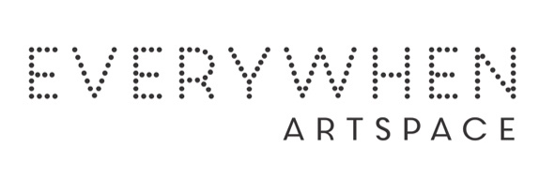ARTIST’S CV

Nancy Wungundin

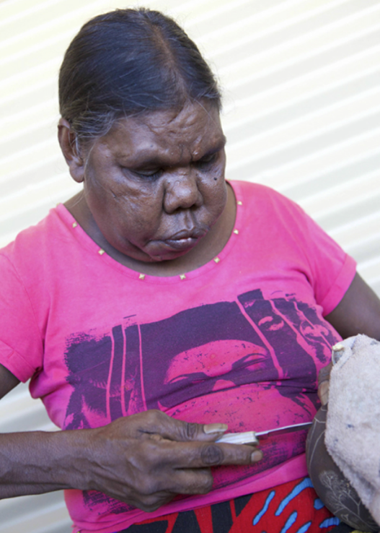

Born: 1960
Clan: Ngaryinyin

Nancy Wungundin grew up in Imintji on the Gibb River Road. With a deep understanding of cultural knowledge and protocol, Nancy loves remembering her country and the cave sites that her old people took her to visit as a child.
The designs in Nancy's paintings are contemporary, yet always maintain a strong connection with the traditional cave paintings of her ancestors. In the past Nancy was a highly skilled carver of boab nuts and based on her high level of craftsmanship has facilitated carving workshops.

Group Exhibition
2026 Bunarri Anja (Many Birds & Wandjinas), Everywhen Artspace, Mornington Peninsula, VIC

