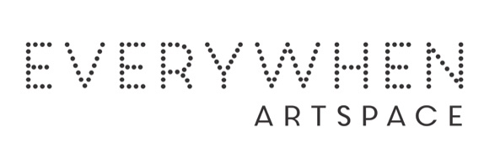Artists Bio CV

Philinka Ngordagoot Dolby

Skin: Djingun
Language: Ngarinyin
Country: Pantijan

Philinka first began painting in 2005. She has been nurtured by Gabriella and Gordon Barunga (two of Mowanjum's most accomplished senior artists) and has always been surrounded by artists at work. Philinka has 8 children. Her early paintings show a strong sense of design with bold shapes and flat areas of colour. Philinka’s bubbly personality and youthful exuberance add a delightful spark to the Mowamjum art studio.
Since 2024 Philinka is not only an artist for Mowanjum but also part of the arts worker team.
She participated in several workshops - ceramics, Fashion and Design workshop and print making.

Group Exhibitions
2026 Bunarri Anja (Many Birds & Wandjinas), Everywhen Artspace, Mornington Peninsula, VIC

