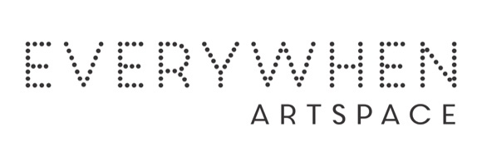ARTIST’S CV

Sandra Mungulu

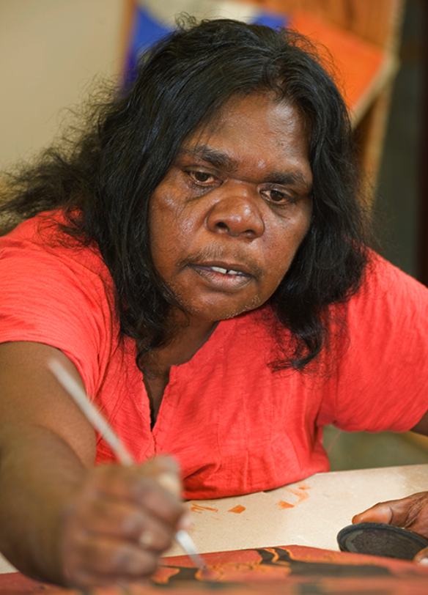

Born: 1961
Clan: Worrora, Wunambal

Sandra is a prolific and passionate painter, renowned internationally for her art which is held in numerous museums and private collections. Sandra began painting almost two decades ago, inspired by observing her famous father in-law David Mowaljarlai create his own Wandjina artwork.

Sandra produces beautifully balanced work, rich in stories and legends that show her strong connection to traditional cultural beliefs. Reflected in Sandra's practice are the original stories and representations told by her ancestors to younger generations. To Sandra, it is vital that these stories are passed on, refreshed and remembered.

Sandra belongs to the Mungulu dynasty of painters which includes her mother Gudu, sisters Marjorie, Margaret, Mildred and Robyn. Her two daughters, Carmen and Deidre, are now also painting and her son Aaron is creating pearl shell jewellery.

Group Exhibtions:
2026 Bunarri Anja (Many Birds & Wandjinas), Everywhen Artspace, Mornington Peninsula, VIC
2017 Paintings & prints Derby Christmas Markets
2017 Paintings Tarnanthi Art Fair, Adelaide, SA
2017 Paintings Darwin Art Fair, Darwin, NT
2009 Sharing Difference on Common Ground, Holmes a Court Gallery & touring nationally
2009 Mowanjum Festival, Mowanjum Art and Culture Centre, Derby, WA
2009 Kimberley Art Prize, Derby, WA
2008 Shinju Matsuri Wandjina Budda Budding, Broome 6 Gallery, WA
2008 Mowanjum Festival Mowanjum Art and Culture Centre
2008 Kimberley Art Prize, Derby, WA
2008 Cultural Connections, Artitja Art Gallery Perth, WA
2008 Spirit of the Wandjina , Shinju Matsuri Exhibition Broome 6 Gallery, WA
2007 MowanjumFestival, Mowanjum Art and Culture Centre, Derby, WA
2007 Arralululai, Broome 6 Gallery, WA
2007 Mowanjum Exhibition, Woodford Dreaming Festival, QLD
2006 Spirit of the Wandjina, Governor Stirling Tower, Perth, WA
2006 Power of the Wandjina, Macquarie University Sydney, NSW
2005 Spirit of the Wandjina, Broome 6 Gallery, WA
2005 Keeping the Wandjinas Fresh, Exhibition and book launch, Alexander Library Perth, WA
2005 Mowanjum Festival
2005 Mowanjum Exhibition, Festival of the Dreaming Woodford, QLD
2004 Mowanjum Exhibition, Sydney Dreaming Festival, NSW
2004 Mowanjum Festival, Derby, WA
2003 Mowanjum Festival, Derby, WA
2003 Spirit of the Wandjina, Harvey Bay QLD
2002 Visions from the Cave, Sun Picture Theatre, Broome, WA
2002 Mowanjum Festival, Derby, WA
2001 Recent Works, Melbourne Spirit of the Wandjina Gallery, VIC
2001 Mowanjum Festival, Derby, WA
2000 The Art of the Wandjina, Sydney Olympics Exhibition, NSW
2000 Spirit of the Wandjina, Compass Travel Postonja Slovenia
2000 Mowanjum Festival, Derby, WA
2000 Spirit of the Wandjina Exhibition, Melbourne, VIC
1999 5th Telstra Art Award, Museum and Art Gallery of the NT, Darwin, NT
1999 Power of the Wandjina, Telstra National Headquarters, Melbourne, NT
1999 Recent Works, Spirit of the Wandjina Gallery, Melbourne, VIC
1999 Power of the Wandjina, Governor Stirling Tower, Perth, WA
1999 Spirit of the Wandjina Exhibition, Governor Place, Sydney, NSW
1999 Mowanjum Festival, Derby, WA
1998 Spirit of the Wandjina, Telstra National Headquarters, Melbourne, VIC
1998 Mowanjum Festival, Derby, WA
1998 Mowanjum Wandjina Art, Matzo’s Broome, WA
1998 Spirit of the Wandjina, Grosvenor Place, Sydney, NSW

Collections
Numerous private collections
Wallungunder Lai Lai, sold for $21,000 to private collector in Los Angeles
Publications
Sotheby’s Catalogue November 2007, Collaborative work by Mowanjum Artists including Sandra Mungulu $35,000 sold to Los Angeles Museum

