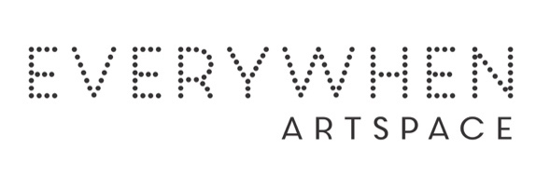ARTIST’S CV

Barbara Arndie Bear
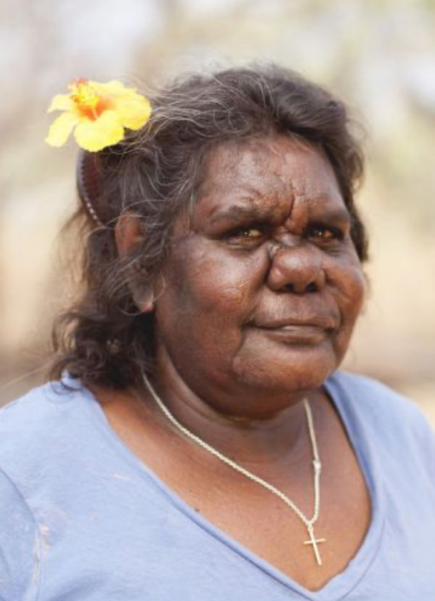

Born: 1959
Clan: Ngarinyin

Barbara is a Ngarinyin woman and is the fourth child of nine children. She has lived in Derby and Mowanjum most of her life.
Barbara’s work is unique within the Art Centre. Her colour palette, defined shapes and decorative detailing, sees her work reveal a distinctive graphic look. Though contemporary in her approach her work is always informed by the traditional stories heard from her elders as a child.

Group Exhibitions
2026 Bunarri Anja (Many Birds & Wandjinas), Everywhen Artspace, Mornington Peninsula, VIC
2019 Revealed, Fremantle Art Centre, Fremantle, WA
2017 REVEALED: Emerging Aboriginal Western Australian Artists Fremantle Arts Centre WA

