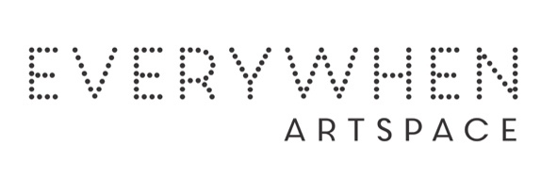ARTIS’S CV

Mildred Minggi Mungulu
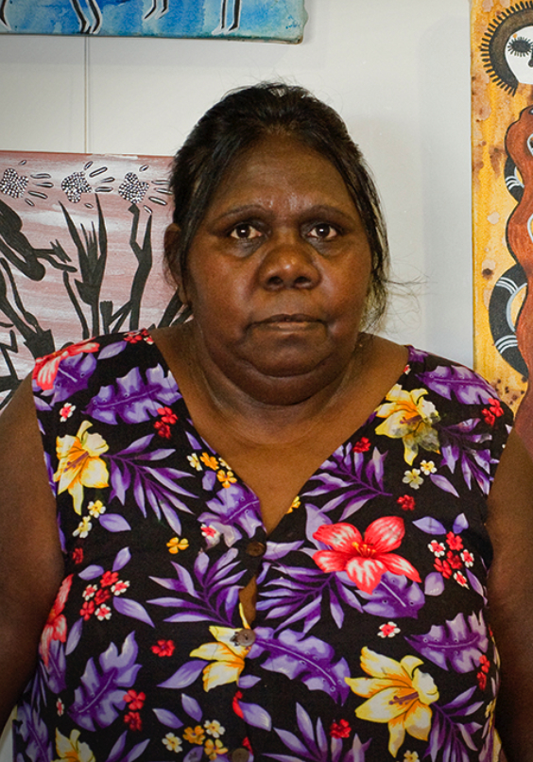

Born: 1957
Clan: Worrorra

Mildred was born at Wotjulum, an intermediate site used by the Mowanjum community following the Second World War. It was here that she watched her father Alan Mungulu make didgeridoos and boomerangs at home. The traditional crafting of these objects supported Mildred’s connection to traditional culture, and inspired her later work as a painter.
Mildred started her career as an exhibiting artist in 1998 and belongs to one of the most established traditional families in Mowanjum, and is a part of the familial artistic dynasty lead by Gudu Mungulu. She has exhibited in Sydney, Perth, Derby, Broome and Woodford, Queensland.
She is a disciplined painter with a strong eye for detail, design and movement. Skilful in her use of colour, Mildred’s paintings have a mystical quality and often combine Gyorn Gyorn figures with Wandjina Spirits.

Group Exhibitions
2026 Bunarri Anja (Many Bird & Wandjinas) Mowanjum show, Everywhen Artspace, Mornington Peninsula, VIC
2024 Mowanjum Wandjina's, Hobart, Tasmania
2024 Revealed, Fremantle Art Centre, Fremantle, WA
2023 Prints Taranthi Online
2023 Prints Darwin Aboriginal Art Fair
2022 Paintings, Taranthi
2022 Painting, Darwin Aboriginal Art Fair
2021 Paintings, Taranthi
2021 Painting, Darwin Aboriginal Art Fair
2017 Derby Christmas Markets
2017 Sydney Opera House Sydney Homeground Markets
2017 Tarnanthi Art Fair (Adelaide, South Australia)
2017 Darwin Art Fair
2017 Emerging Aboriginal Western Australian Artists (Fremantle Gallery - Perth) Revealed
2009 Sharing Difference on Common Ground – Holmes a Court Gallery & touring nationally 2009 Mowanjum Festival – Mowanjum Art and Culture Centre, Derby 2008 Shinju Matsuri Wandjina Budda Budding – Broome 6 Gallery 2008 Mowanjum Festival Mowanjum Art Centre
2008 Cultural Connections - Arittja Art Gallery Perth 2008 Spirit of the Wandjina - Shinju Matsuri Exhibition Broome 6 Gallery 2007 Mowanjum Festival - Mowanjum Art and Culture Centre, Derby
2007 Arralululai - Broome 6 Gallery 2007 Mowanjum Exhibition - Woodford Dreaming Festival, QLD
2006 Spirit of the Wandjina - Governor Stirling Tower, Perth
2006 Power of the Wandjina - Macquarie University Sydney
2005 Spirit of the Wandjina - Broome 6 Gallery 2005 Keeping the Wandjinas Fresh Exhibition and book launch - Alexander Library Perth 2005 Mowanjum Festival Mowanjum Community 2005 Mowanjum Exhibition - Festival of the Dreaming Woodford, QLD 2004 Mowanjum Exhibition - Sydney Dreaming Festival
2004 Mowanjum Festival - Mowanjum Community
2003 Mowanjum Festival - Mowanjum Community 2003 Spirit of the Wandjina - Harvey Bay QLD
2002 Visions from the Cave - Sun Picture Theatre, Broome
2002 Mowanjum Festival - Mowanjum Community
2001 Recent Works - Melbourne Spirit of the Wandjina Gallery
2001 Mowanjum Festival - Mowanjum Community
2000 The Art of the Wandjina - Sydney Olympics Exhibition, NSW
2000 Spirit of the Wandjina - Compass Travel Postonja Slovenia
2000 Mowanjum Festival - Mowanjum Community
2000 Spirit of the Wandjina Exhibition – Melbourne
1999 Power of the Wandjina - Telstra National Headquarters – Melbourne 1999 Recent Works - Spirit of the Wandjina Gallery, Melbourne
1999 Power of the Wandjina - Governor Stirling Tower, Perth
1999 Spirit of the Wandjina Exhibition - Governor Place, Sydney
1999 Mowanjum Festival - Mowanjum Community
1998 Spirit of the Wandjina - Telstra National Headquarters, Melbourne 1998 Mowanjum Festival - Mowanjum Community
1998 Mowanjum Wandjina Art – Matzo’s Broome
1998 Spirit of the Wandjina – Grosvenor Place, Sydney
1997 Mowanjum Festival - Mowanjum Community
Commissions:
2000 Sydney Olympics Opening Ceramony – Large Scale Sculpture

