ARTIST’S CV

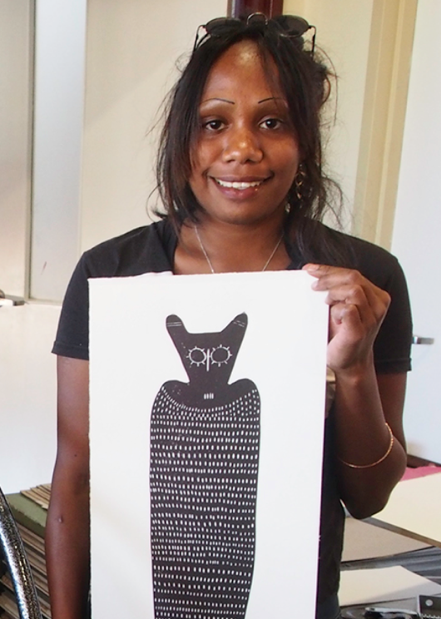
PETRINA BEDFORD

Born: 1998
Language: Ngarinyin

Petrina Bedford is a third-generation contemporary indigenous artist. Both her maternal grandfather Jack Dale Mengenen and her paternal grandfather Nyunkuny Paddy Bedford are famous Kimberley painters (now deceased). Encouraged by Jack Dale, Petrina painted from a very young age, first exhibiting paintings at a commercial gallery at age twelve.
Petrina uses her own contemporary style when painting, but she turns to traditional subject matter to reflect the Wandjina and classical stories passed down through her family. Her painting utilises bright colour to play with line, shape and form.

Group Exhibitions:
2026 Bunarri Anja (Many Birds & Wandjinas), Everywhen Artspace, Mornington Peninsula, VIC
2017 Sydney Opera House Homeground Markets, Sydney, NSW Revealed, Fremantle Art Centre, Perth, WA
2016 Paintings & prints – Reveal, Thelma Johns, Perth, WA
2016 Jack Dale - A Kimberley History
Bibliography
2015 'Mowanjum Daytrip,' Philippa Jahn, Desert River Sea, Art Gallery of Western Australia
Commissions
2000 Sydney Olympics Opening Ceremony – Large Scale Sculpture

