**Mark Nodea**

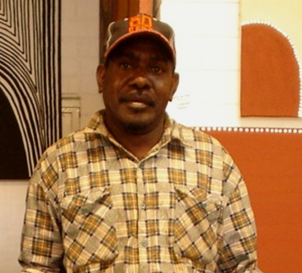 **BORN** 1970  
**LANGUAGE GROUP G**ija  
**REGION** East Kimberley

Mark Nodea is one of the most exciting artists of his generation in Warmun today. Informed by the oral histories and culture of his Gija country and the contemporary environment, his works are bold, strong and deep in character.

As a child growing up in the 1970's and 80's Mark was schooled in the two-way learning, founded by renowned Warmun artists including Queenie McKenzie, Hector Jandany, Jack Britten and Rover Thomas at the Ngalangangpum School, which saw the beginning of the Contemporary Art Movement in Warmun.

This two-way education gave Mark a strong grounding in Gija language and culture, alongside western education, which informs his practice today. Mark paints his mother, artist Nancy Nodea's Ngarrgooroon country which extends around Texas Station and down south to Purnululu.

In 2001 Mark produced a design for a limited edition silver dollar commemorative coin for the Royal Australian Mint, which featured a fleet-footed bounding Kangaroo. The Royal Australian Mint has only released 10 such coins since 1983.

In 2013, Mark was awarded the City of Greater Geraldton Award for Excellence at the 2013 Mid-West Art Prize.

**SOLO EXHIBITIONS**2003 Alison Kelly Gallery, Melbourne, Vic

**GROUP EXHIBITIONS**   
2019 Desert River Sea, AGWA, Perth WA  
2019 Midwest Art Prize Exhibition, Geraldton Regional Art Gallery, WA GIJA Exhibition, Woolloongabba Art Gallery, QLD   
2018 GIJA Exhibition, Woolloongabba Art Gallery, QLD   
2014 Warmun Aboriginal Art - Art Images Gallery, Adelaide, SA  
2013 5th Annual Belle Arti Prize Exhibition  
2008 East of East Kimberley, ReDot Gallery, Singapore  
2006 Warmun Art Centre Presents, Mary Place Gallery, Sydney, NSW 2005 Warmun Group Show, Framed Gallery, Darwin, NT   
2003 'Group Show', Framed Gallery, Darwin, NT  
2003 'East Kimberley Show', Short Street Gallery, Broome, WA  
2002 Coomalie Culture Centre, Batchelor, NT  
2002 'All That Gija Country', Flinder's University Art Museum, Adelaide, SA 2002 Thornquest Gallery, Gold Coast, QLD  
2002 'New Works from Warmun Community' (Turkey Creek), Framed Gallery, Darwin, NT  
2001 'In celebration - The Peter Bailiee Aquisitive Exhibition', Flinders University Art Museum

**AWARDS**2002 Kimberley Interpreting Centre, Designer of image for medical poster 2002 Royal Australian Mint, Canberra, designer of 10th Commemorative Silver dollar

**COLLECTIONS**   
Queensland Art Gallery, ArtBank