Antonia Napangardi Michaels

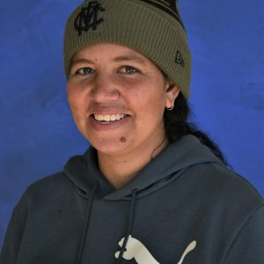

Birth date: 6/3/1998
Birthplace: Alice Springs, NT
Language: Warlpiri
Antonia Napangardi Michaels was born on the 6 March 1998 in Alice Springs Hospital, the closest hospital to Nyirripi, a remote aboriginal community located approximately 420 km north-west of Alice Springs and approx. 130 km north-west of Yuendumu, in the Northern Territory of Australia. She is the daughter of Andrea Nungarrayi Wilson and Chris Japanangka Michaels and granddaughter of Alice Nampijinpa Henworth, all major Warlpiri artists. Antonia went to St Mary’s School in Broome, graduating in 2012. When she finished school, she came back to Nyirripi and worked at the Learning Centre run by the Batchelor Institute, an Indigenous Tertiary Education Program, where Antonia assisted students with computer skills.
Antonia began painting with Warlukurlangu Artists Aboriginal Corporation, an Aboriginal owned and governed art centre located in Yuendumu and Nyirripi, in 2010 when she was 12 years old and again in 2014 when she was 16. Antonia continues the family tradition of artists painting her Grandmother’s Lappi Lappi Jukurrpa (Lappi Lappi Dreaming) and her father’s Janganpa Jukurrpa (Bush-tailed Possum Dreaming), stories which relate directly to her land, its features and the plants and animals that inhabit it. These stories were passed down to her by her Parents and their parents before them for millennia. She learnt to paint first at school and then by watching all the family paint. She uses an unrestricted palette to depict her traditional iconography, at the same time developing a modern individualist style, using pattern in a variety of contexts.
Antonia is married to Maxie Jampijinpa Pollard and has one son born in 2017. When she is not painting, or working she loves to go hunting for bush tucker with family and friends.

Exhibitions

2026 At Home with Art – Women’s Show | Everywhen Art, Shoreham, VIC
2025 Tanami Treasures |art from Warlukurlangu Artists, Art Mob, Hobart, TAS
2025 Warlukurlangu Artists: Tarngangka Jkau Pirrjirdi Nyarni Pantirini Jaku | Continuing to Paint Strong, Yaama Ganu Gallery, Moree, NSW
2023 New works from WARLUKURLANGU, Flinders Lane Gallery, Melbourne, VIC
2022 Painting Words, Cooee Gallery, Redfern, NSW
2022 Out Bush: Warlu 2022, Flinders Lane Gallery, Melbourne, VIC
2021 We Choose to Challenge, Coo-ee Fine Art Gallery, Sydney, NSW
2020 New Works from Community, Flinders Lane Gallery, Melbourne, VIC

