Fibre Fun!
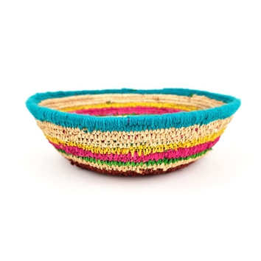 | Angelina Malbunka  Basket, 2022  raffia  10 x 27 cm  (MM5864) | $ 148.50
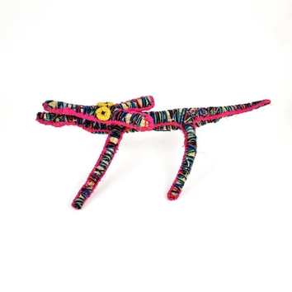 | Antoinette Williamson  Papa (Dog), 2022  tjanpi (grass), acrylic wool, raffia  20 x 50 x 30 cm  (MM5865) | $ 264.00
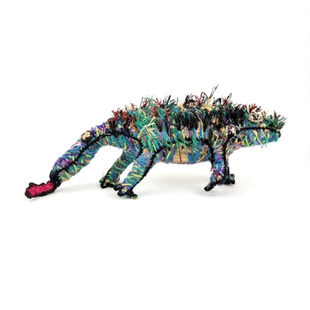 | Cynthia Burke  Tjilkamarta (Echidna), 2022  tjanpi (grass), acrylic wool, raffia  20 x 60 x 15 cm  (MM5861) | $ 363.00
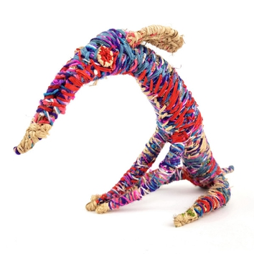 | Cynthia Burke  Papa (Dog), 2022  tjanpi (grass), acrylic wool, raffia  30 x 50 x 25 cm  (MM5866) | $ 297.00
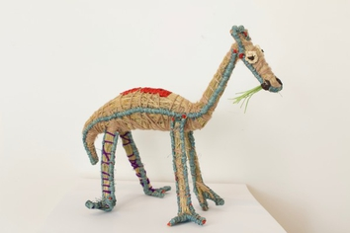 | Danielle Cooley  Kamula (Camel), 2022  tjanpi (grass), acrylic wool, raffia  24 x 37 x 16 cm  (MM5862) | $ 280.50
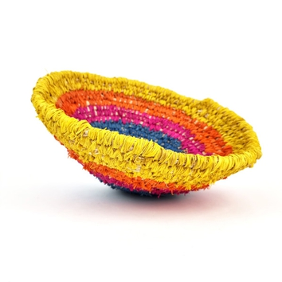 | Elizabeth Smith  Basket, 2022  raffia  30 x 50 cm  (MM5863) | $ 280.50
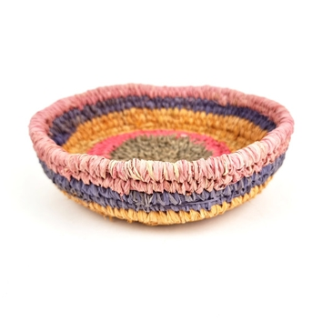 | Erica Shorty  Basket, 2022  raffia  6 x 20 cm  (MM5867) | $ 132.00
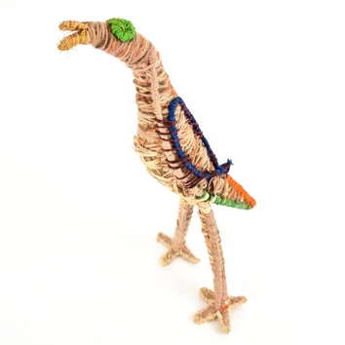 | Erica Shorty  Tjulpu (Bird), 2022  tjanpi (grass), acrylic wool, raffia  40 x 15 x 20 cm  (MM5868) | $ 264.00
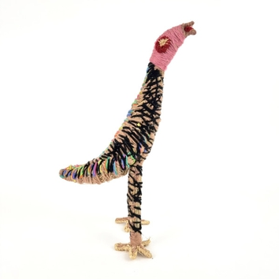 | Erica Shorty  Tjulpu (Bird), 2022  tjanpi (grass), acrylic wool. raffia  41 x 25 x 15 cm  (MM5869) | $ 280.50
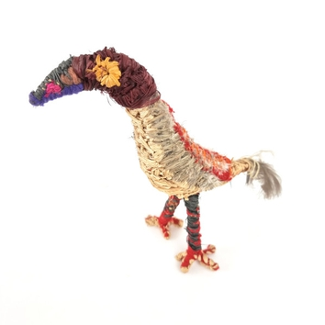 | Erica Shorty  Tjulpu (Bird), 2022  tjanpi (grass), acrylic wool, raffia  30 x 20 x 15 cm  (MM5871) | $ 231.00
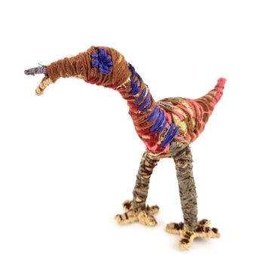 | Erica Shorty  Tjulpu (Bird), 2022  tjanpi (grass), acrylic wool, raffia  23 x 23 x 17 cm  (MM5872) | $ 247.50
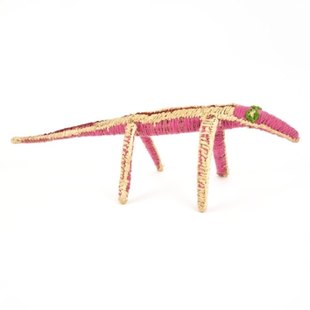 | Erica Shorty  Tinka (Lizard), 2022  tjanpi (grass), acrylic wool, raffia  20 x 65 x 20 cm  (MM5873) | $ 247.50
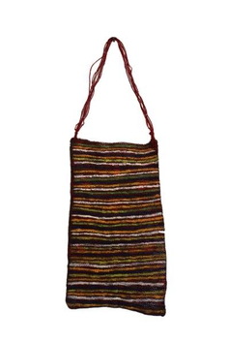 | Joy Wilfred  Yir (Dilly Bag), 2021  acrylic on reclaimed materials  48 x 29 cm  (MM5891) | $ 134.00
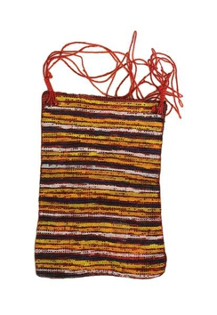 | Joy Wilfred  Yir (Dilly Bag), 2021  acrylic on reclaimed materials  26.5 x 20 cm  (MM5892) | $ 93.00
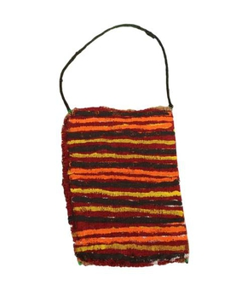 | Joy Wilfred  Yir (Dilly Bag), 2021  acrylic on reclaimed materials  25 x 18 cm  (MM5893) | $ 93.00
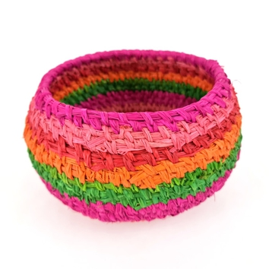 | Julie Anderson  Basket, 2022  raffia  15 x 24 cm  (MM5848) | $ 181.50
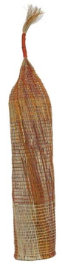 | Maureen Ali  An-gujechiya (Fish Trap), 2021  pandanus and bush cane with natural dyes  157 x 26 x 25 cm  (MM5797) | $ 2,800.00
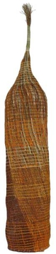 | Maureen Ali  An-gujechiya (Fish Trap), 2021  pandanus and bush cane with natural dyes  155 x 26 x 25 cm  (MM5798) | $ 2,800.00
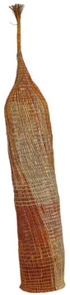 | Maureen Ali  An-gujechiya (Fish Trap), 2021  pandanus and bush cane with natural dyes  156 x 27 x 27 cm  (MM5799) | $ 2,800.00
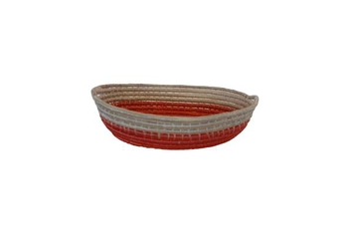 | Mawungumain Nundhirribala  Wulbung (Basket), 2022  woven reclaimed ghost net  4.5 x 21 x 18 cm  (MM5884) | $ 150.00
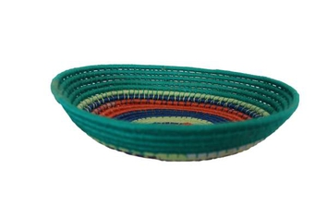 | Mawungumain Nundhirribala  Wulbung (Basket), 2022  woven reclaimed ghost net  6 x 22 x 24 cm  (MM5885) | $ 180.00
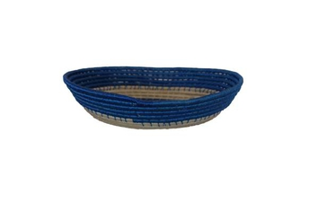 | Mawungumain Nundhirribala  Wulbung (Basket), 2022  woven reclaimed ghost net  6 x 26 x 24 cm  (MM5886) | $ 235.00
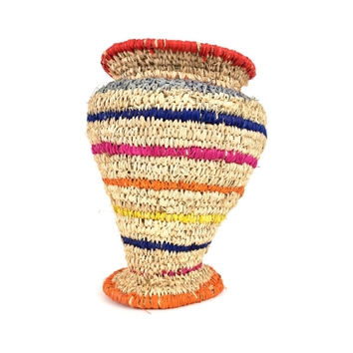 | Ngilan (Margaret) Dodd  Basket, 2022  tjanpi (grass), raffia  35 x 27 cm  (MM5845) | $ 495.00
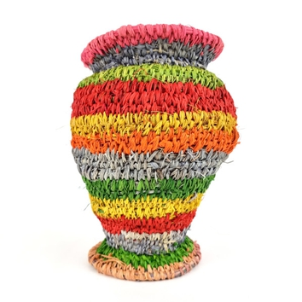 | Ngilan (Margaret) Dodd  Basket, 2022  raffia  27 x 21 cm  (MM5850) | $ 363.00
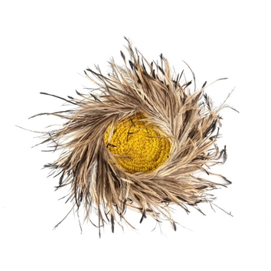 | Ngoi Ngoi Donald  Basket, 2022  raffia, wipya (emu feathers)  7 x 30 cm  (MM5846) | $ 148.50
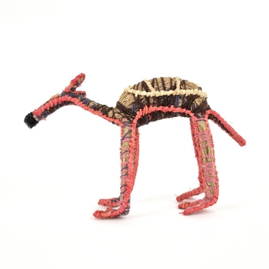 | Pinuka (Margaret) Yai Yai  Kamula (Camel), 2022  tjanpi (grass), acrylic wool, raffia  26 x 14 x 37 cm  (MM5847) | $ 280.50
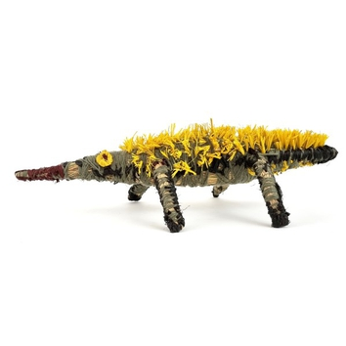 | Ruth Bates  Tjilkamarta (Echidna), 2022  tjanpi (grass), acrylic wool, raffia  12 x 27 x 54 cm  (MM5855) | $ 264.00
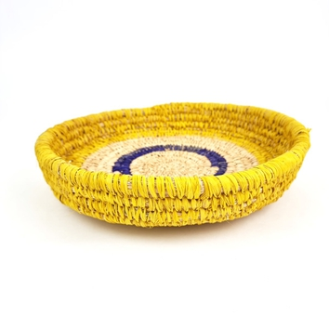 | Sheryth Bronson  Basket, 2022  tjanpi (grass), raffia  8 x 32 cm  (MM5859) | $ 264.00
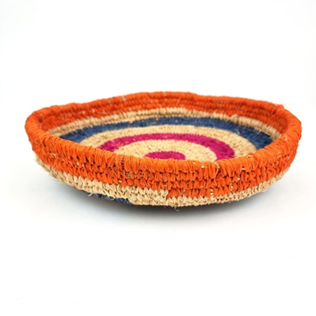 | Sheryth Bronson  Basket, 2022  tjanpi (grass), raffia  6 x 30 cm  (MM5860) | $ 264.00
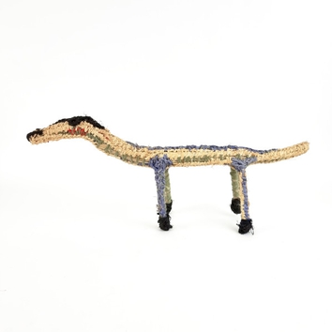 | Tjunkaya Tapaya  Tinka (Lizard), 2022  tjanpi (grass), acrylic wool, raffia  29 x 65 x 14 cm  (MM5853) | $ 231.00
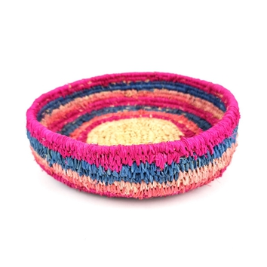 | Vanessa Calma  Basket, 2022  raffia  6 x 24 cm  (MM5854) | $ 181.50
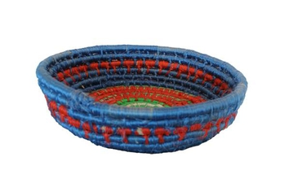 | Yulki Nunggumjbarr  Wulbung (Basket), 2021  woven reclaimed ghost net  10 x 39 x 37 cm  (MM5887) | $ 550.00
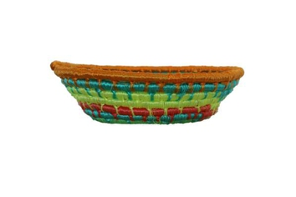 | Yulki Nunggumjbarr  Wulbung (Basket), 2021  woven reclaimed ghost net  9 x 31 x 30.5 cm  (MM5888) | $ 360.00
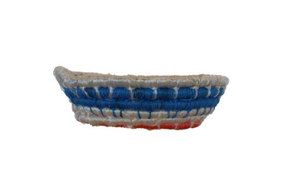 | Yulki Nunggumjbarr  Wulbung (Basket), 2021  woven reclaimed ghost net  8 x 27 x 27.5 cm  (MM5889) | $ 230.00
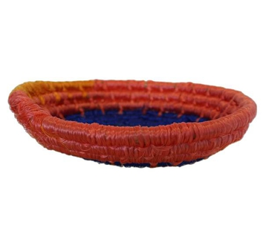 | Yulki Nunggumjbarr  Wulbung (Basket), 2021  woven reclaimed ghost net  5.5 x 24 x 23 cm  (MM5890) | $ 215.00

